Laboratorium 8

## BIG_0001.jpg fragment: x=290, y=316, width=128, height=128

### 4:4:4, neutral Quantization

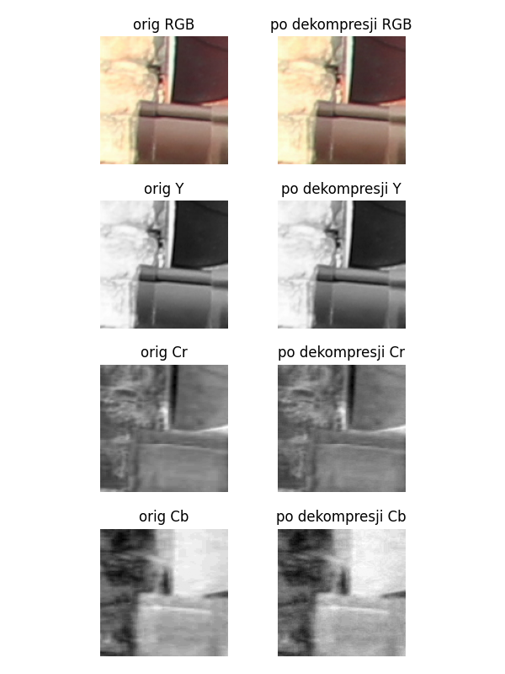

|  |  |  |  |
| --- | --- | --- | --- |
| Layer | Original Size | Compressed Size | Compression Ratio |
| Y | 16384 | 25004 | 152.61% |
| Cr | 16384 | 15566 | 95.01% |
| Cb | 16384 | 12178 | 74.33% |
| Total | 49152 | 52748 | 107.32% |

Compression Statistics - 4:4:4, neutral Quantization

RLE without layer compression:

|  |  |  |  |
| --- | --- | --- | --- |
| Layer | Original Size | Compressed Size | Compression Ratio |
| Y | 16384 | 26051 | 159.00% |
| Cr | 16384 | 16353 | 99.81% |
| Cb | 16384 | 10825 | 66.07% |
| Total | 49152 | 53229 | 108.29% |

### 4:2:2, neutral Quantization

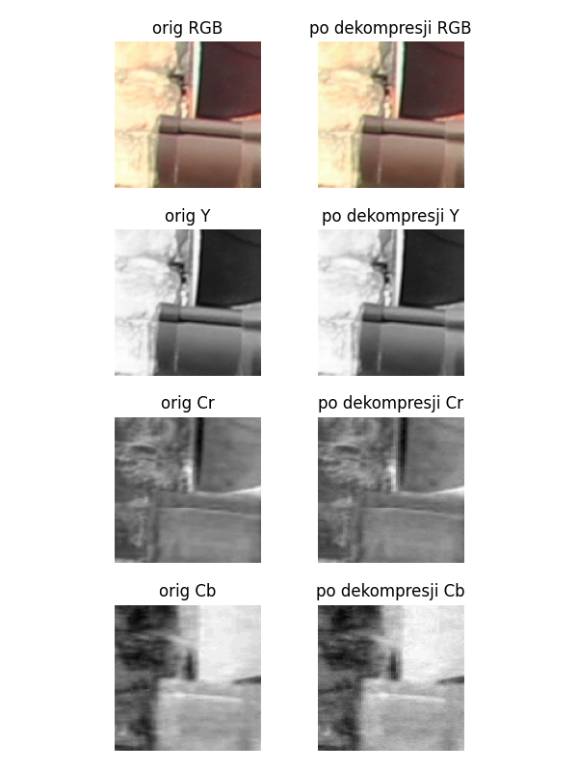

|  |  |  |  |
| --- | --- | --- | --- |
| Layer | Original Size | Compressed Size | Compression Ratio |
| Y | 16384 | 25004 | 152.61% |
| Cr | 8192 | 9336 | 113.96% |
| Cb | 8192 | 7440 | 90.82% |
| Total | 32768 | 41780 | 127.50% |

Compression Statistics - 4:2:2, neutral Quantization

RLE without layer compression:

|  |  |  |  |
| --- | --- | --- | --- |
| Layer | Original Size | Compressed Size | Compression Ratio |
| Y | 16384 | 26051 | 159.00% |
| Cr | 16384 | 16353 | 99.81% |
| Cb | 16384 | 10825 | 66.07% |
| Total | 49152 | 53229 | 108.29% |

### 4:4:4, Lumination 50% Quantization

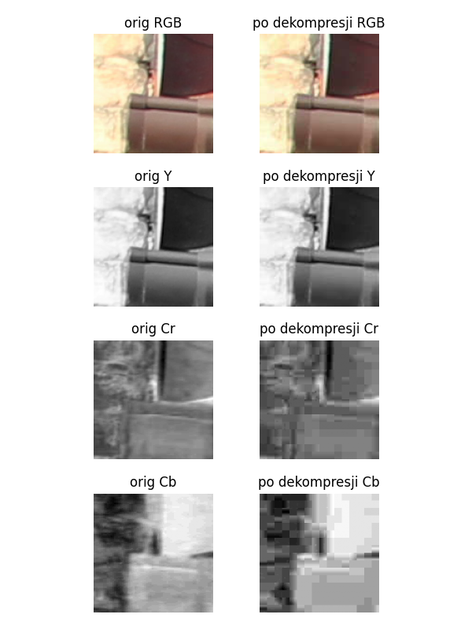

|  |  |  |  |
| --- | --- | --- | --- |
| Layer | Original Size | Compressed Size | Compression Ratio |
| Y | 16384 | 4432 | 27.05% |
| Cr | 16384 | 1622 | 9.90% |
| Cb | 16384 | 1334 | 8.14% |
| Total | 49152 | 7388 | 15.03% |

Compression Statistics - 4:4:4, Lumination 50% Quantization

RLE without layer compression:

|  |  |  |  |
| --- | --- | --- | --- |
| Layer | Original Size | Compressed Size | Compression Ratio |
| Y | 16384 | 26051 | 159.00% |
| Cr | 16384 | 16353 | 99.81% |
| Cb | 16384 | 10825 | 66.07% |
| Total | 49152 | 53229 | 108.29% |

### 4:2:2, Lumination 50% Quantization

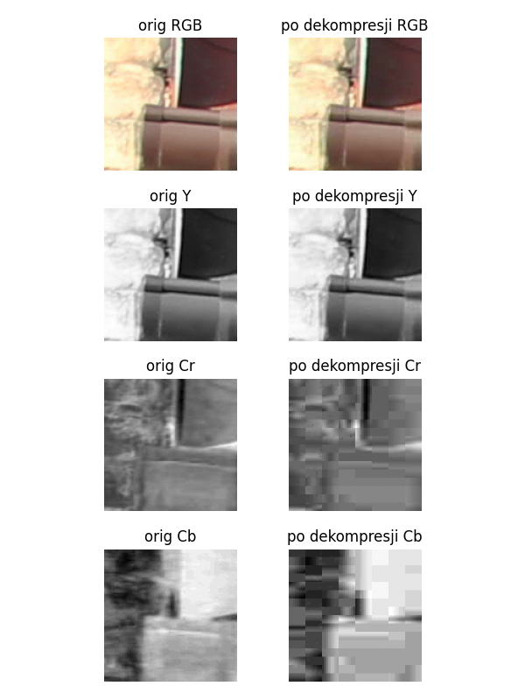

|  |  |  |  |
| --- | --- | --- | --- |
| Layer | Original Size | Compressed Size | Compression Ratio |
| Y | 16384 | 4432 | 27.05% |
| Cr | 8192 | 906 | 11.06% |
| Cb | 8192 | 700 | 8.54% |
| Total | 32768 | 6038 | 18.43% |

Compression Statistics - 4:2:2, Lumination 50% Quantization

RLE without layer compression:

|  |  |  |  |
| --- | --- | --- | --- |
| Layer | Original Size | Compressed Size | Compression Ratio |
| Y | 16384 | 26051 | 159.00% |
| Cr | 16384 | 16353 | 99.81% |
| Cb | 16384 | 10825 | 66.07% |
| Total | 49152 | 53229 | 108.29% |

## BIG_0001.jpg fragment: x=3946, y=609, width=128, height=128

### 4:4:4, neutral Quantization

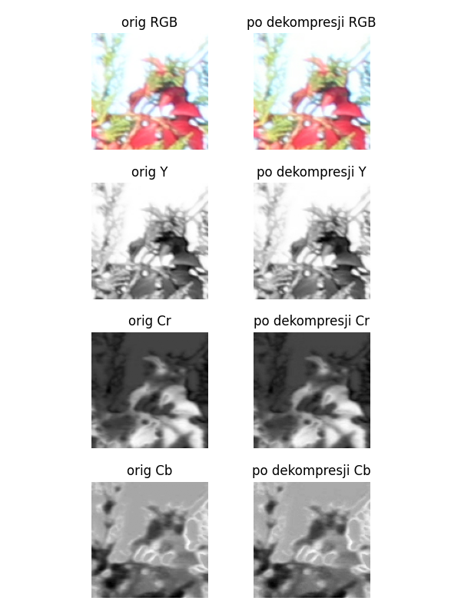

|  |  |  |  |
| --- | --- | --- | --- |
| Layer | Original Size | Compressed Size | Compression Ratio |
| Y | 16384 | 25568 | 156.05% |
| Cr | 16384 | 20366 | 124.30% |
| Cb | 16384 | 19056 | 116.31% |
| Total | 49152 | 64990 | 132.22% |

Compression Statistics - 4:4:4, neutral Quantization

RLE without layer compression:

|  |  |  |  |
| --- | --- | --- | --- |
| Layer | Original Size | Compressed Size | Compression Ratio |
| Y | 16384 | 25821 | 157.60% |
| Cr | 16384 | 23653 | 144.37% |
| Cb | 16384 | 21475 | 131.07% |
| Total | 49152 | 70949 | 144.35% |

### 4:2:2, neutral Quantization

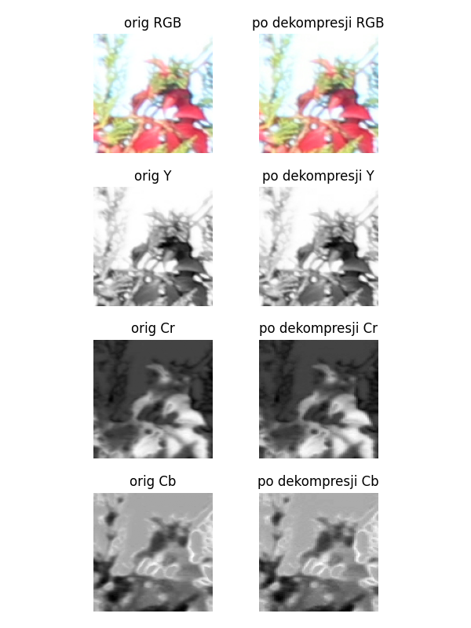

|  |  |  |  |
| --- | --- | --- | --- |
| Layer | Original Size | Compressed Size | Compression Ratio |
| Y | 16384 | 25568 | 156.05% |
| Cr | 8192 | 11822 | 144.31% |
| Cb | 8192 | 11128 | 135.84% |
| Total | 32768 | 48518 | 148.07% |

Compression Statistics - 4:2:2, neutral Quantization

RLE without layer compression:

|  |  |  |  |
| --- | --- | --- | --- |
| Layer | Original Size | Compressed Size | Compression Ratio |
| Y | 16384 | 25821 | 157.60% |
| Cr | 16384 | 23653 | 144.37% |
| Cb | 16384 | 21475 | 131.07% |
| Total | 49152 | 70949 | 144.35% |

### 4:4:4, Lumination 50% Quantization

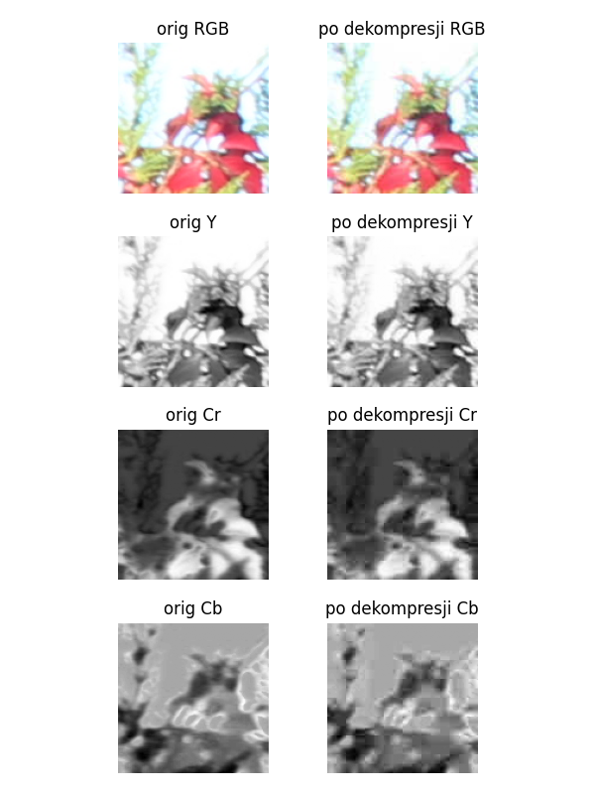

|  |  |  |  |
| --- | --- | --- | --- |
| Layer | Original Size | Compressed Size | Compression Ratio |
| Y | 16384 | 6264 | 38.23% |
| Cr | 16384 | 2504 | 15.28% |
| Cb | 16384 | 2084 | 12.72% |
| Total | 49152 | 10852 | 22.08% |

Compression Statistics - 4:4:4, Lumination 50% Quantization

RLE without layer compression:

|  |  |  |  |
| --- | --- | --- | --- |
| Layer | Original Size | Compressed Size | Compression Ratio |
| Y | 16384 | 25821 | 157.60% |
| Cr | 16384 | 23653 | 144.37% |
| Cb | 16384 | 21475 | 131.07% |
| Total | 49152 | 70949 | 144.35% |

### 4:2:2, Lumination 50% Quantization

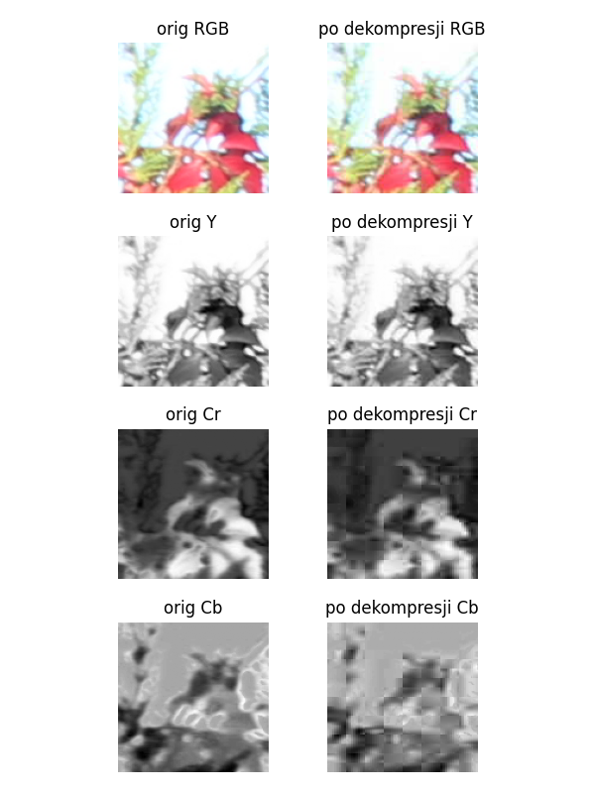

|  |  |  |  |
| --- | --- | --- | --- |
| Layer | Original Size | Compressed Size | Compression Ratio |
| Y | 16384 | 6264 | 38.23% |
| Cr | 8192 | 1508 | 18.41% |
| Cb | 8192 | 1218 | 14.87% |
| Total | 32768 | 8990 | 27.44% |

Compression Statistics - 4:2:2, Lumination 50% Quantization

RLE without layer compression:

|  |  |  |  |
| --- | --- | --- | --- |
| Layer | Original Size | Compressed Size | Compression Ratio |
| Y | 16384 | 25821 | 157.60% |
| Cr | 16384 | 23653 | 144.37% |
| Cb | 16384 | 21475 | 131.07% |
| Total | 49152 | 70949 | 144.35% |

## BIG_0001.jpg fragment: x=838, y=2623, width=128, height=128

### 4:4:4, neutral Quantization

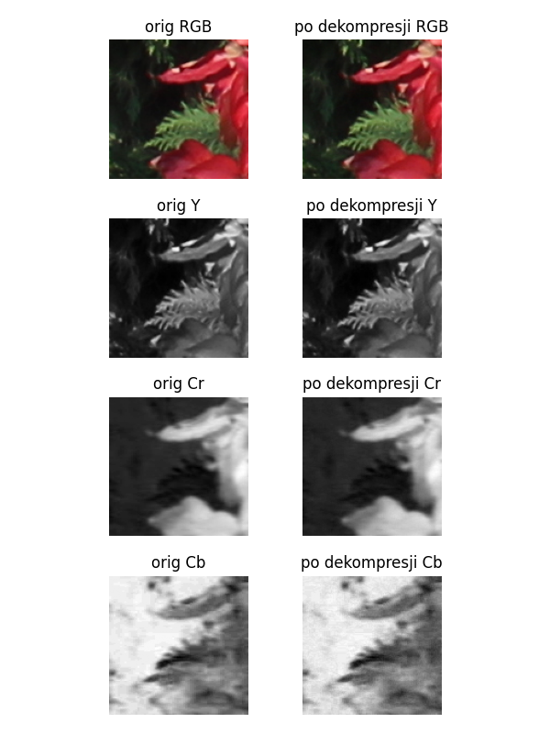

|  |  |  |  |
| --- | --- | --- | --- |
| Layer | Original Size | Compressed Size | Compression Ratio |
| Y | 16384 | 26986 | 164.71% |
| Cr | 16384 | 16202 | 98.89% |
| Cb | 16384 | 13778 | 84.09% |
| Total | 49152 | 56966 | 115.90% |

Compression Statistics - 4:4:4, neutral Quantization

RLE without layer compression:

|  |  |  |  |
| --- | --- | --- | --- |
| Layer | Original Size | Compressed Size | Compression Ratio |
| Y | 16384 | 28373 | 173.18% |
| Cr | 16384 | 18705 | 114.17% |
| Cb | 16384 | 13011 | 79.41% |
| Total | 49152 | 60089 | 122.25% |

### 4:2:2, neutral Quantization

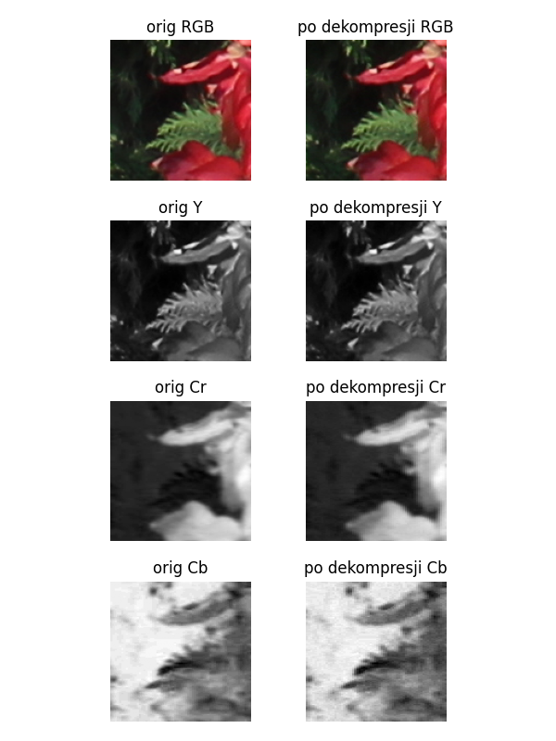

|  |  |  |  |
| --- | --- | --- | --- |
| Layer | Original Size | Compressed Size | Compression Ratio |
| Y | 16384 | 26986 | 164.71% |
| Cr | 8192 | 9768 | 119.24% |
| Cb | 8192 | 8522 | 104.03% |
| Total | 32768 | 45276 | 138.17% |

Compression Statistics - 4:2:2, neutral Quantization

RLE without layer compression:

|  |  |  |  |
| --- | --- | --- | --- |
| Layer | Original Size | Compressed Size | Compression Ratio |
| Y | 16384 | 28373 | 173.18% |
| Cr | 16384 | 18705 | 114.17% |
| Cb | 16384 | 13011 | 79.41% |
| Total | 49152 | 60089 | 122.25% |

### 4:4:4, Lumination 50% Quantization

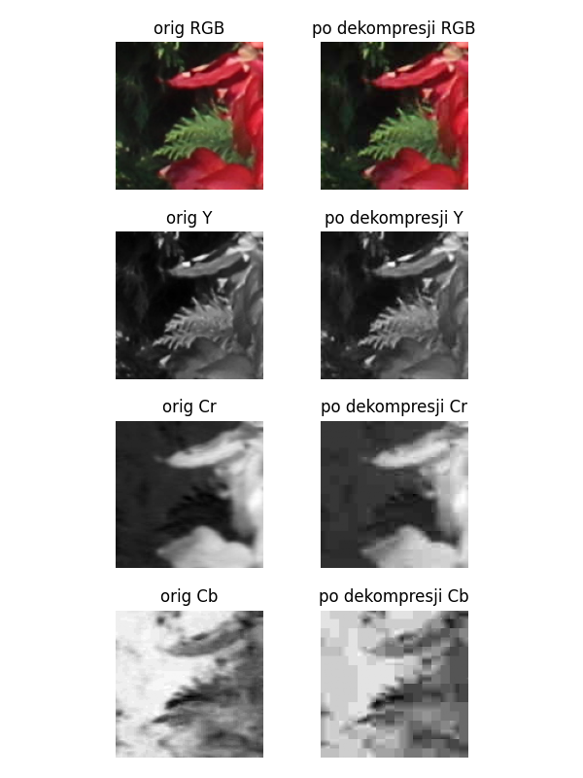

|  |  |  |  |
| --- | --- | --- | --- |
| Layer | Original Size | Compressed Size | Compression Ratio |
| Y | 16384 | 5998 | 36.61% |
| Cr | 16384 | 1836 | 11.21% |
| Cb | 16384 | 1370 | 8.36% |
| Total | 49152 | 9204 | 18.73% |

Compression Statistics - 4:4:4, Lumination 50% Quantization

RLE without layer compression:

|  |  |  |  |
| --- | --- | --- | --- |
| Layer | Original Size | Compressed Size | Compression Ratio |
| Y | 16384 | 28373 | 173.18% |
| Cr | 16384 | 18705 | 114.17% |
| Cb | 16384 | 13011 | 79.41% |
| Total | 49152 | 60089 | 122.25% |

### 4:2:2, Lumination 50% Quantization

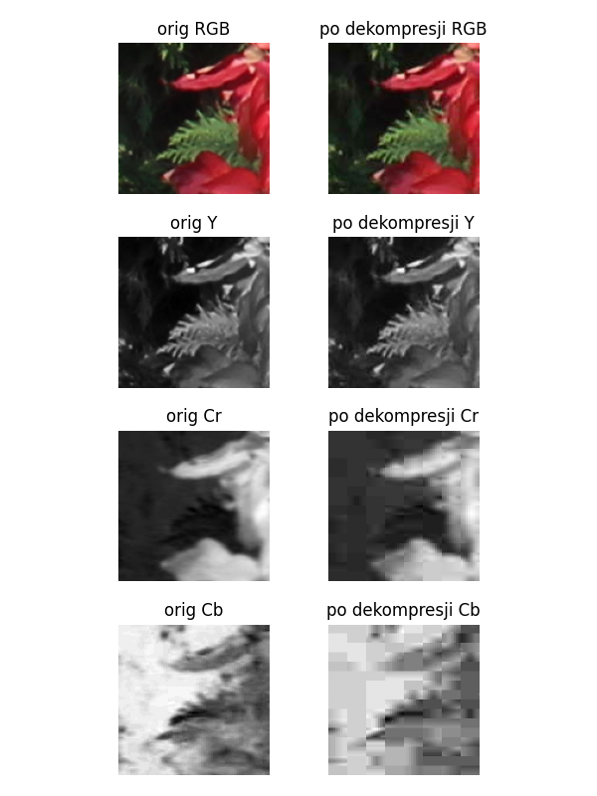

|  |  |  |  |
| --- | --- | --- | --- |
| Layer | Original Size | Compressed Size | Compression Ratio |
| Y | 16384 | 5998 | 36.61% |
| Cr | 8192 | 1122 | 13.70% |
| Cb | 8192 | 772 | 9.42% |
| Total | 32768 | 7892 | 24.08% |

Compression Statistics - 4:2:2, Lumination 50% Quantization

RLE without layer compression:

|  |  |  |  |
| --- | --- | --- | --- |
| Layer | Original Size | Compressed Size | Compression Ratio |
| Y | 16384 | 28373 | 173.18% |
| Cr | 16384 | 18705 | 114.17% |
| Cb | 16384 | 13011 | 79.41% |
| Total | 49152 | 60089 | 122.25% |

## BIG_0001.jpg fragment: x=3764, y=2851, width=128, height=128

### 4:4:4, neutral Quantization

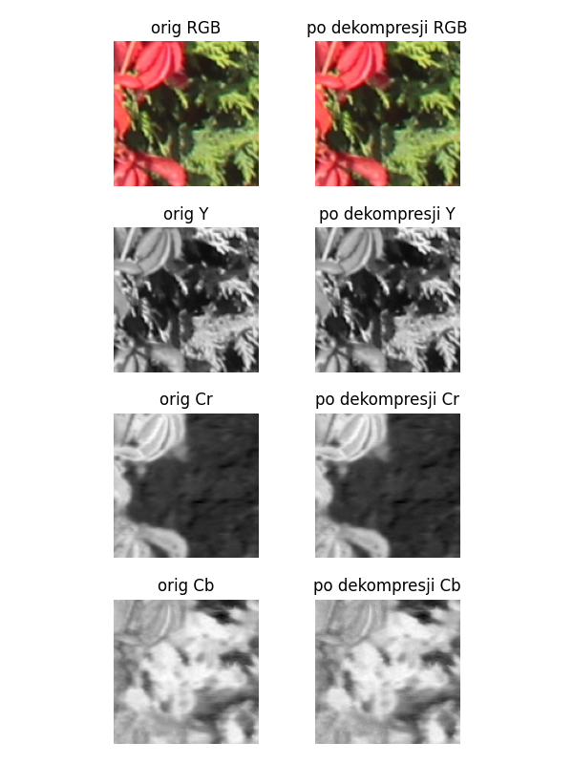

|  |  |  |  |
| --- | --- | --- | --- |
| Layer | Original Size | Compressed Size | Compression Ratio |
| Y | 16384 | 30282 | 184.83% |
| Cr | 16384 | 20484 | 125.02% |
| Cb | 16384 | 20114 | 122.77% |
| Total | 49152 | 70880 | 144.21% |

Compression Statistics - 4:4:4, neutral Quantization

RLE without layer compression:

|  |  |  |  |
| --- | --- | --- | --- |
| Layer | Original Size | Compressed Size | Compression Ratio |
| Y | 16384 | 30975 | 189.06% |
| Cr | 16384 | 23779 | 145.14% |
| Cb | 16384 | 23859 | 145.62% |
| Total | 49152 | 78613 | 159.94% |

### 4:2:2, neutral Quantization

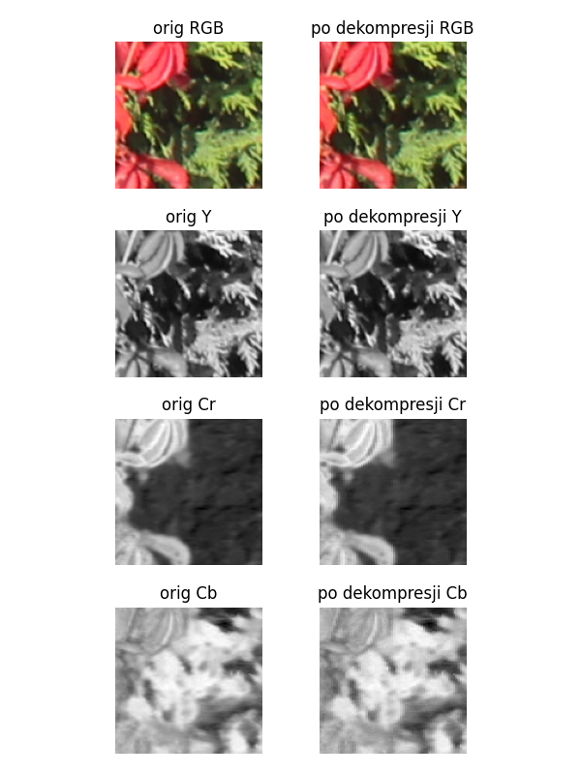

|  |  |  |  |
| --- | --- | --- | --- |
| Layer | Original Size | Compressed Size | Compression Ratio |
| Y | 16384 | 30282 | 184.83% |
| Cr | 8192 | 12182 | 148.71% |
| Cb | 8192 | 11728 | 143.16% |
| Total | 32768 | 54192 | 165.38% |

Compression Statistics - 4:2:2, neutral Quantization

RLE without layer compression:

|  |  |  |  |
| --- | --- | --- | --- |
| Layer | Original Size | Compressed Size | Compression Ratio |
| Y | 16384 | 30975 | 189.06% |
| Cr | 16384 | 23779 | 145.14% |
| Cb | 16384 | 23859 | 145.62% |
| Total | 49152 | 78613 | 159.94% |

### 4:4:4, Lumination 50% Quantization

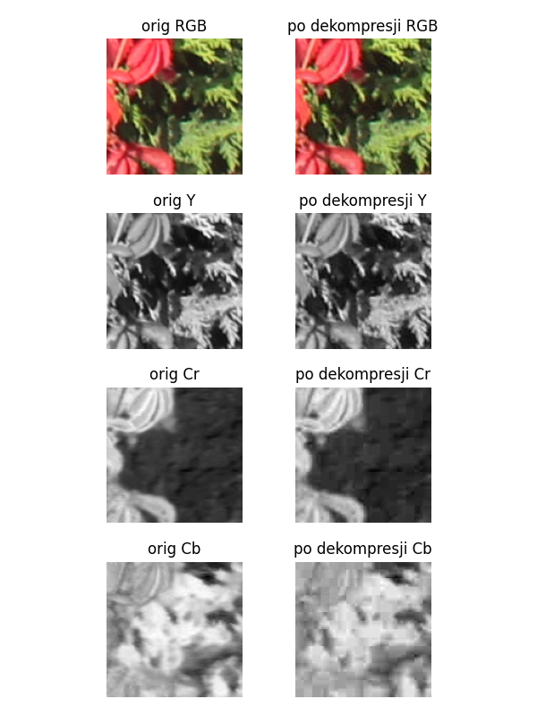

|  |  |  |  |
| --- | --- | --- | --- |
| Layer | Original Size | Compressed Size | Compression Ratio |
| Y | 16384 | 8544 | 52.15% |
| Cr | 16384 | 2314 | 14.12% |
| Cb | 16384 | 2180 | 13.31% |
| Total | 49152 | 13038 | 26.53% |

Compression Statistics - 4:4:4, Lumination 50% Quantization

RLE without layer compression:

|  |  |  |  |
| --- | --- | --- | --- |
| Layer | Original Size | Compressed Size | Compression Ratio |
| Y | 16384 | 30975 | 189.06% |
| Cr | 16384 | 23779 | 145.14% |
| Cb | 16384 | 23859 | 145.62% |
| Total | 49152 | 78613 | 159.94% |

### 4:2:2, Lumination 50% Quantization

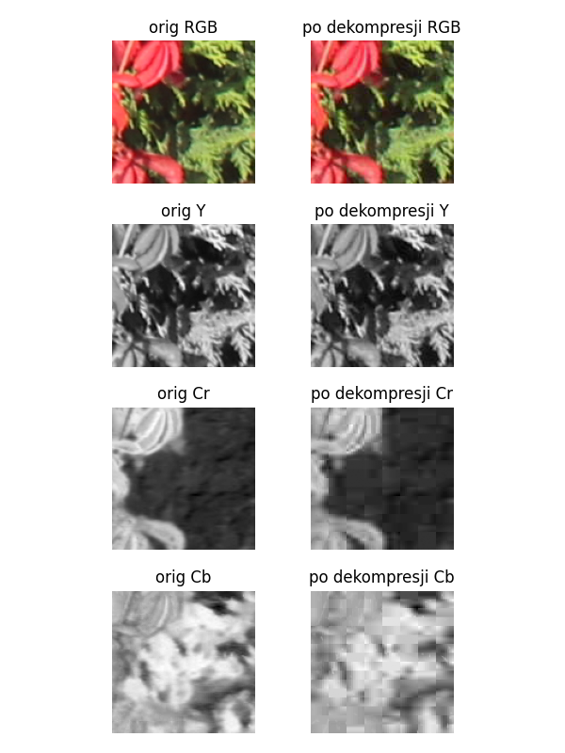

|  |  |  |  |
| --- | --- | --- | --- |
| Layer | Original Size | Compressed Size | Compression Ratio |
| Y | 16384 | 8544 | 52.15% |
| Cr | 8192 | 1356 | 16.55% |
| Cb | 8192 | 1294 | 15.80% |
| Total | 32768 | 11194 | 34.16% |

Compression Statistics - 4:2:2, Lumination 50% Quantization

RLE without layer compression:

|  |  |  |  |
| --- | --- | --- | --- |
| Layer | Original Size | Compressed Size | Compression Ratio |
| Y | 16384 | 30975 | 189.06% |
| Cr | 16384 | 23779 | 145.14% |
| Cb | 16384 | 23859 | 145.62% |
| Total | 49152 | 78613 | 159.94% |

## BIG_0002.jpg fragment: x=706, y=1629, width=128, height=128

### 4:4:4, neutral Quantization

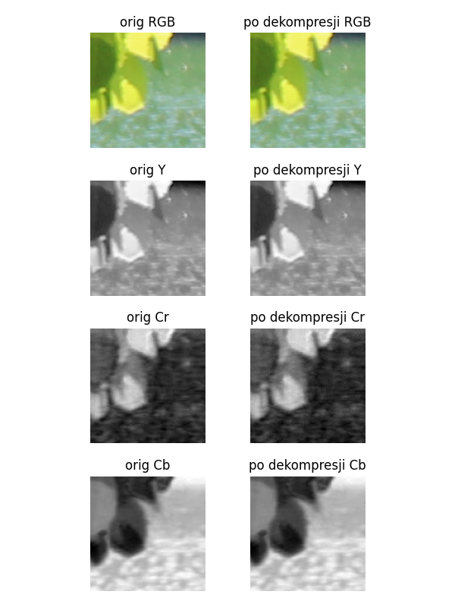

|  |  |  |  |
| --- | --- | --- | --- |
| Layer | Original Size | Compressed Size | Compression Ratio |
| Y | 16384 | 25744 | 157.13% |
| Cr | 16384 | 15248 | 93.07% |
| Cb | 16384 | 17070 | 104.19% |
| Total | 49152 | 58062 | 118.13% |

Compression Statistics - 4:4:4, neutral Quantization

RLE without layer compression:

|  |  |  |  |
| --- | --- | --- | --- |
| Layer | Original Size | Compressed Size | Compression Ratio |
| Y | 16384 | 26667 | 162.76% |
| Cr | 16384 | 15757 | 96.17% |
| Cb | 16384 | 20297 | 123.88% |
| Total | 49152 | 62721 | 127.61% |

### 4:2:2, neutral Quantization

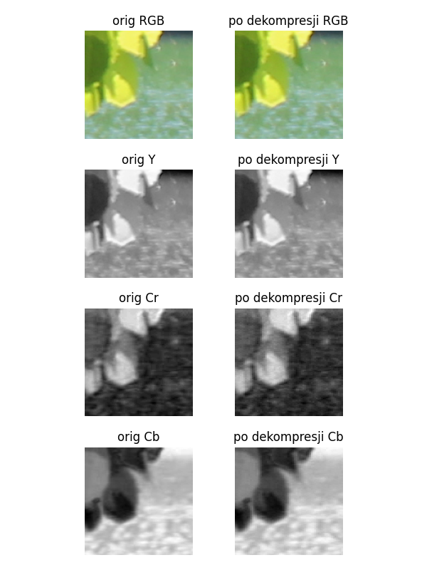

|  |  |  |  |
| --- | --- | --- | --- |
| Layer | Original Size | Compressed Size | Compression Ratio |
| Y | 16384 | 25744 | 157.13% |
| Cr | 8192 | 9120 | 111.33% |
| Cb | 8192 | 10320 | 125.98% |
| Total | 32768 | 45184 | 137.89% |

Compression Statistics - 4:2:2, neutral Quantization

RLE without layer compression:

|  |  |  |  |
| --- | --- | --- | --- |
| Layer | Original Size | Compressed Size | Compression Ratio |
| Y | 16384 | 26667 | 162.76% |
| Cr | 16384 | 15757 | 96.17% |
| Cb | 16384 | 20297 | 123.88% |
| Total | 49152 | 62721 | 127.61% |

### 4:4:4, Lumination 50% Quantization

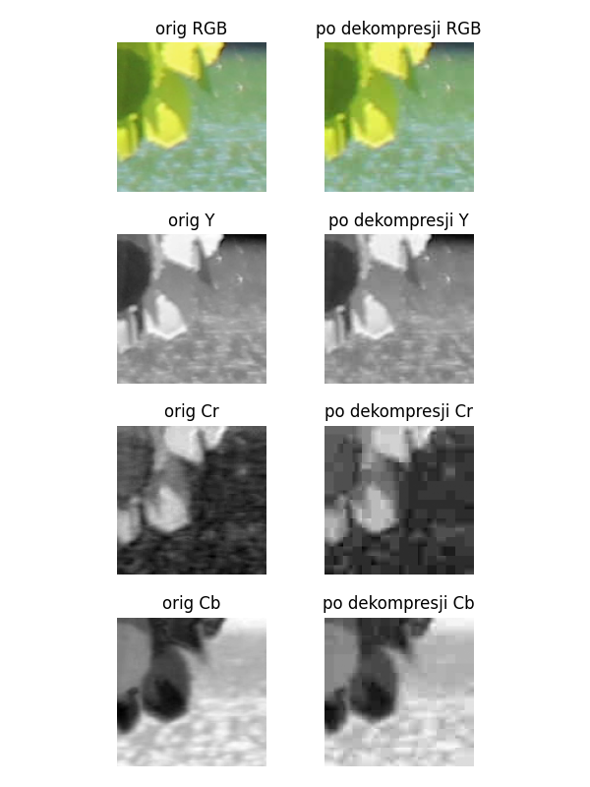

|  |  |  |  |
| --- | --- | --- | --- |
| Layer | Original Size | Compressed Size | Compression Ratio |
| Y | 16384 | 4314 | 26.33% |
| Cr | 16384 | 1442 | 8.80% |
| Cb | 16384 | 1974 | 12.05% |
| Total | 49152 | 7730 | 15.73% |

Compression Statistics - 4:4:4, Lumination 50% Quantization

RLE without layer compression:

|  |  |  |  |
| --- | --- | --- | --- |
| Layer | Original Size | Compressed Size | Compression Ratio |
| Y | 16384 | 26667 | 162.76% |
| Cr | 16384 | 15757 | 96.17% |
| Cb | 16384 | 20297 | 123.88% |
| Total | 49152 | 62721 | 127.61% |

### 4:2:2, Lumination 50% Quantization

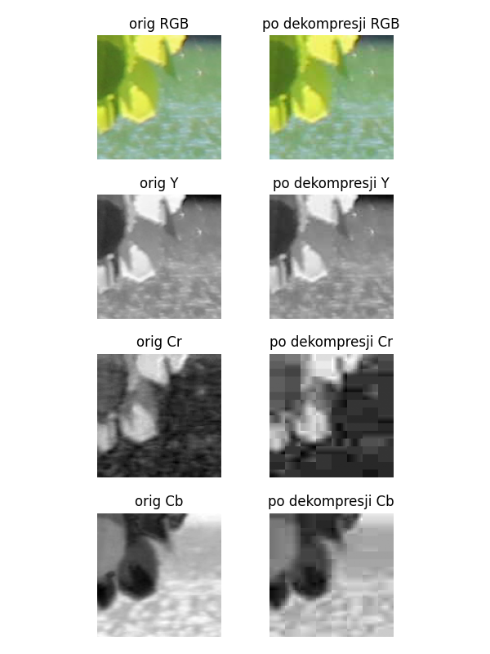

|  |  |  |  |
| --- | --- | --- | --- |
| Layer | Original Size | Compressed Size | Compression Ratio |
| Y | 16384 | 4314 | 26.33% |
| Cr | 8192 | 822 | 10.03% |
| Cb | 8192 | 1236 | 15.09% |
| Total | 32768 | 6372 | 19.45% |

Compression Statistics - 4:2:2, Lumination 50% Quantization

RLE without layer compression:

|  |  |  |  |
| --- | --- | --- | --- |
| Layer | Original Size | Compressed Size | Compression Ratio |
| Y | 16384 | 26667 | 162.76% |
| Cr | 16384 | 15757 | 96.17% |
| Cb | 16384 | 20297 | 123.88% |
| Total | 49152 | 62721 | 127.61% |

## BIG_0002.jpg fragment: x=2520, y=1538, width=128, height=128

### 4:4:4, neutral Quantization

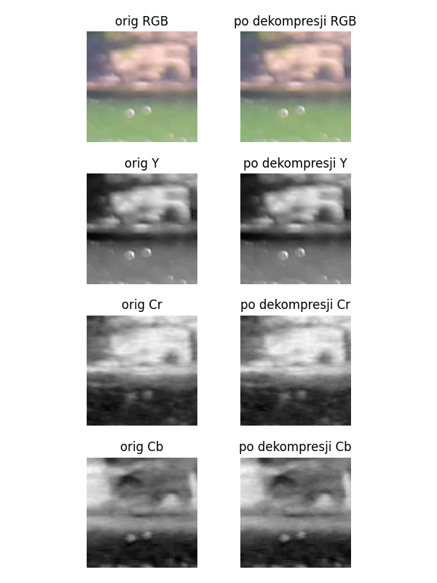

|  |  |  |  |
| --- | --- | --- | --- |
| Layer | Original Size | Compressed Size | Compression Ratio |
| Y | 16384 | 22378 | 136.58% |
| Cr | 16384 | 12194 | 74.43% |
| Cb | 16384 | 12284 | 74.98% |
| Total | 49152 | 46856 | 95.33% |

Compression Statistics - 4:4:4, neutral Quantization

RLE without layer compression:

|  |  |  |  |
| --- | --- | --- | --- |
| Layer | Original Size | Compressed Size | Compression Ratio |
| Y | 16384 | 24687 | 150.68% |
| Cr | 16384 | 10649 | 65.00% |
| Cb | 16384 | 10915 | 66.62% |
| Total | 49152 | 46251 | 94.10% |

### 4:2:2, neutral Quantization

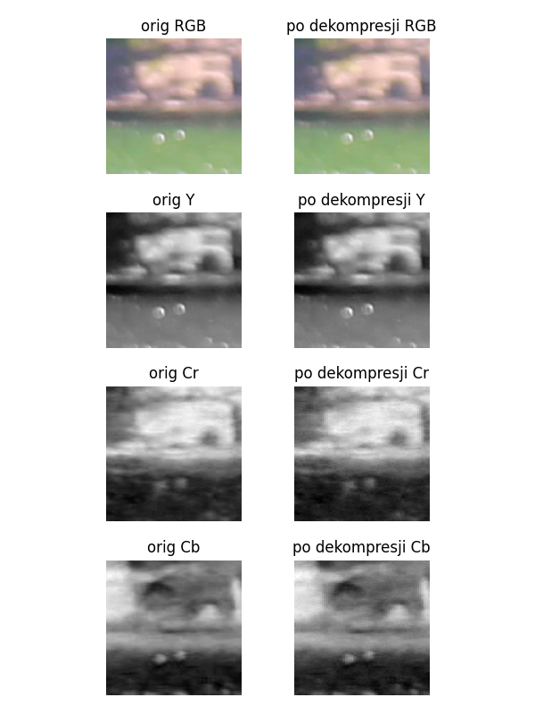

|  |  |  |  |
| --- | --- | --- | --- |
| Layer | Original Size | Compressed Size | Compression Ratio |
| Y | 16384 | 22378 | 136.58% |
| Cr | 8192 | 7944 | 96.97% |
| Cb | 8192 | 7928 | 96.78% |
| Total | 32768 | 38250 | 116.73% |

Compression Statistics - 4:2:2, neutral Quantization

RLE without layer compression:

|  |  |  |  |
| --- | --- | --- | --- |
| Layer | Original Size | Compressed Size | Compression Ratio |
| Y | 16384 | 24687 | 150.68% |
| Cr | 16384 | 10649 | 65.00% |
| Cb | 16384 | 10915 | 66.62% |
| Total | 49152 | 46251 | 94.10% |

### 4:4:4, Lumination 50% Quantization

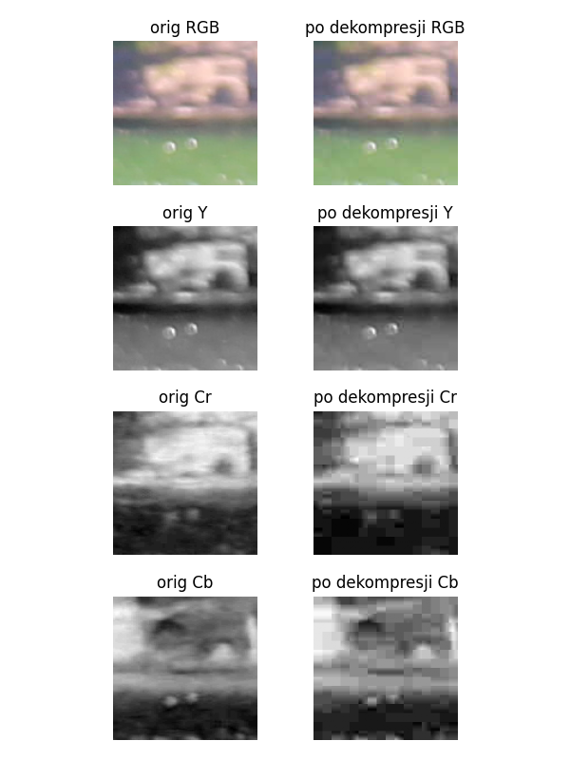

|  |  |  |  |
| --- | --- | --- | --- |
| Layer | Original Size | Compressed Size | Compression Ratio |
| Y | 16384 | 3438 | 20.98% |
| Cr | 16384 | 1464 | 8.94% |
| Cb | 16384 | 1564 | 9.55% |
| Total | 49152 | 6466 | 13.16% |

Compression Statistics - 4:4:4, Lumination 50% Quantization

RLE without layer compression:

|  |  |  |  |
| --- | --- | --- | --- |
| Layer | Original Size | Compressed Size | Compression Ratio |
| Y | 16384 | 24687 | 150.68% |
| Cr | 16384 | 10649 | 65.00% |
| Cb | 16384 | 10915 | 66.62% |
| Total | 49152 | 46251 | 94.10% |

### 4:2:2, Lumination 50% Quantization

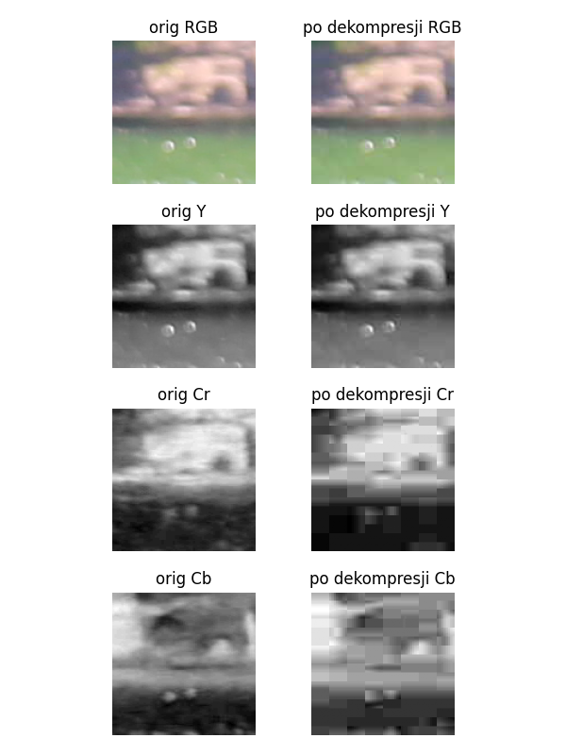

|  |  |  |  |
| --- | --- | --- | --- |
| Layer | Original Size | Compressed Size | Compression Ratio |
| Y | 16384 | 3438 | 20.98% |
| Cr | 8192 | 748 | 9.13% |
| Cb | 8192 | 820 | 10.01% |
| Total | 32768 | 5006 | 15.28% |

Compression Statistics - 4:2:2, Lumination 50% Quantization

RLE without layer compression:

|  |  |  |  |
| --- | --- | --- | --- |
| Layer | Original Size | Compressed Size | Compression Ratio |
| Y | 16384 | 24687 | 150.68% |
| Cr | 16384 | 10649 | 65.00% |
| Cb | 16384 | 10915 | 66.62% |
| Total | 49152 | 46251 | 94.10% |

## BIG_0002.jpg fragment: x=3874, y=2957, width=128, height=128

### 4:4:4, neutral Quantization

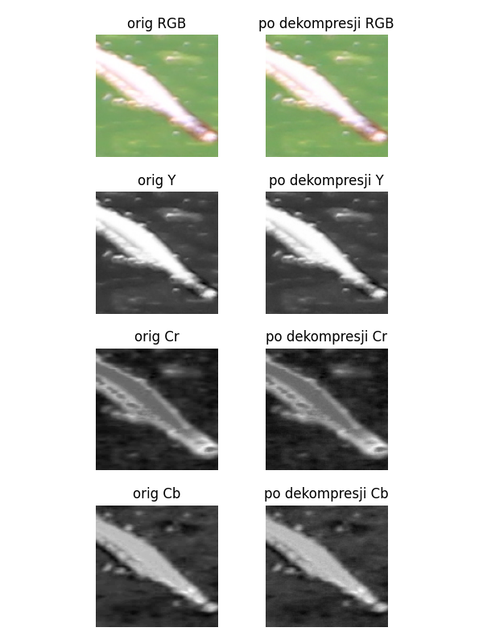

|  |  |  |  |
| --- | --- | --- | --- |
| Layer | Original Size | Compressed Size | Compression Ratio |
| Y | 16384 | 24256 | 148.05% |
| Cr | 16384 | 15452 | 94.31% |
| Cb | 16384 | 15000 | 91.55% |
| Total | 49152 | 54708 | 111.30% |

Compression Statistics - 4:4:4, neutral Quantization

RLE without layer compression:

|  |  |  |  |
| --- | --- | --- | --- |
| Layer | Original Size | Compressed Size | Compression Ratio |
| Y | 16384 | 22487 | 137.25% |
| Cr | 16384 | 14397 | 87.87% |
| Cb | 16384 | 13603 | 83.03% |
| Total | 49152 | 50487 | 102.72% |

### 4:2:2, neutral Quantization

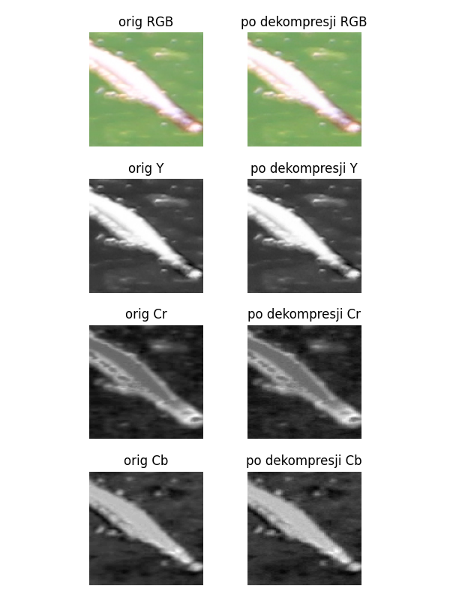

|  |  |  |  |
| --- | --- | --- | --- |
| Layer | Original Size | Compressed Size | Compression Ratio |
| Y | 16384 | 24256 | 148.05% |
| Cr | 8192 | 9396 | 114.70% |
| Cb | 8192 | 9210 | 112.43% |
| Total | 32768 | 42862 | 130.80% |

Compression Statistics - 4:2:2, neutral Quantization

RLE without layer compression:

|  |  |  |  |
| --- | --- | --- | --- |
| Layer | Original Size | Compressed Size | Compression Ratio |
| Y | 16384 | 22487 | 137.25% |
| Cr | 16384 | 14397 | 87.87% |
| Cb | 16384 | 13603 | 83.03% |
| Total | 49152 | 50487 | 102.72% |

### 4:4:4, Lumination 50% Quantization

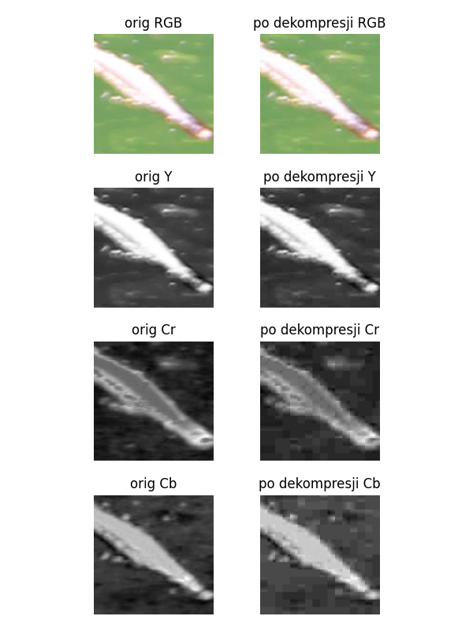

|  |  |  |  |
| --- | --- | --- | --- |
| Layer | Original Size | Compressed Size | Compression Ratio |
| Y | 16384 | 3790 | 23.13% |
| Cr | 16384 | 1662 | 10.14% |
| Cb | 16384 | 1488 | 9.08% |
| Total | 49152 | 6940 | 14.12% |

Compression Statistics - 4:4:4, Lumination 50% Quantization

RLE without layer compression:

|  |  |  |  |
| --- | --- | --- | --- |
| Layer | Original Size | Compressed Size | Compression Ratio |
| Y | 16384 | 22487 | 137.25% |
| Cr | 16384 | 14397 | 87.87% |
| Cb | 16384 | 13603 | 83.03% |
| Total | 49152 | 50487 | 102.72% |

### 4:2:2, Lumination 50% Quantization

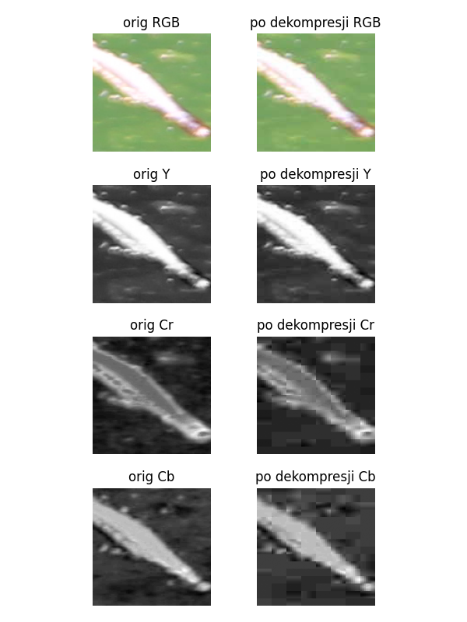

|  |  |  |  |
| --- | --- | --- | --- |
| Layer | Original Size | Compressed Size | Compression Ratio |
| Y | 16384 | 3790 | 23.13% |
| Cr | 8192 | 914 | 11.16% |
| Cb | 8192 | 922 | 11.25% |
| Total | 32768 | 5626 | 17.17% |

Compression Statistics - 4:2:2, Lumination 50% Quantization

RLE without layer compression:

|  |  |  |  |
| --- | --- | --- | --- |
| Layer | Original Size | Compressed Size | Compression Ratio |
| Y | 16384 | 22487 | 137.25% |
| Cr | 16384 | 14397 | 87.87% |
| Cb | 16384 | 13603 | 83.03% |
| Total | 49152 | 50487 | 102.72% |

## BIG_0002.jpg fragment: x=4405, y=1940, width=128, height=128

### 4:4:4, neutral Quantization

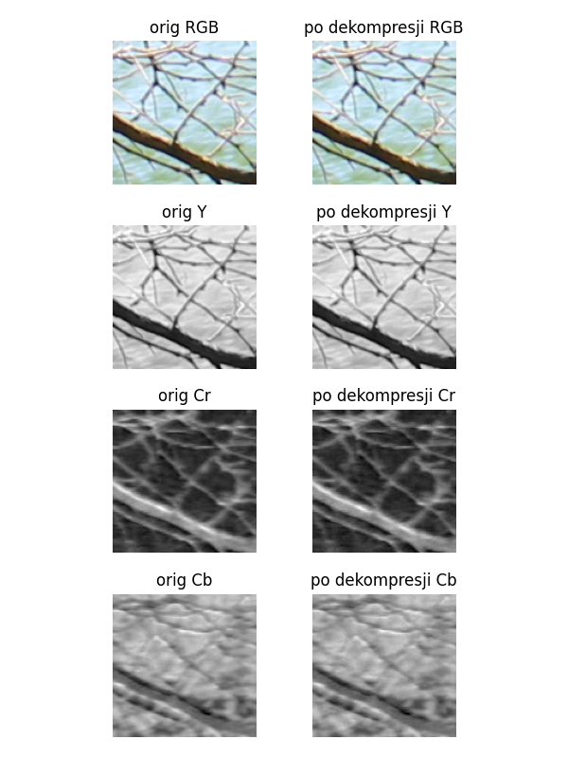

|  |  |  |  |
| --- | --- | --- | --- |
| Layer | Original Size | Compressed Size | Compression Ratio |
| Y | 16384 | 30304 | 184.96% |
| Cr | 16384 | 20964 | 127.95% |
| Cb | 16384 | 21036 | 128.39% |
| Total | 49152 | 72304 | 147.10% |

Compression Statistics - 4:4:4, neutral Quantization

RLE without layer compression:

|  |  |  |  |
| --- | --- | --- | --- |
| Layer | Original Size | Compressed Size | Compression Ratio |
| Y | 16384 | 30183 | 184.22% |
| Cr | 16384 | 22221 | 135.63% |
| Cb | 16384 | 23265 | 142.00% |
| Total | 49152 | 75669 | 153.95% |

### 4:2:2, neutral Quantization

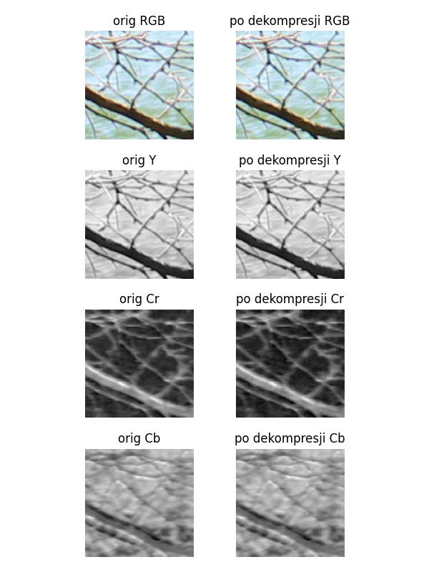

|  |  |  |  |
| --- | --- | --- | --- |
| Layer | Original Size | Compressed Size | Compression Ratio |
| Y | 16384 | 30304 | 184.96% |
| Cr | 8192 | 12034 | 146.90% |
| Cb | 8192 | 12118 | 147.92% |
| Total | 32768 | 54456 | 166.19% |

Compression Statistics - 4:2:2, neutral Quantization

RLE without layer compression:

|  |  |  |  |
| --- | --- | --- | --- |
| Layer | Original Size | Compressed Size | Compression Ratio |
| Y | 16384 | 30183 | 184.22% |
| Cr | 16384 | 22221 | 135.63% |
| Cb | 16384 | 23265 | 142.00% |
| Total | 49152 | 75669 | 153.95% |

### 4:4:4, Lumination 50% Quantization

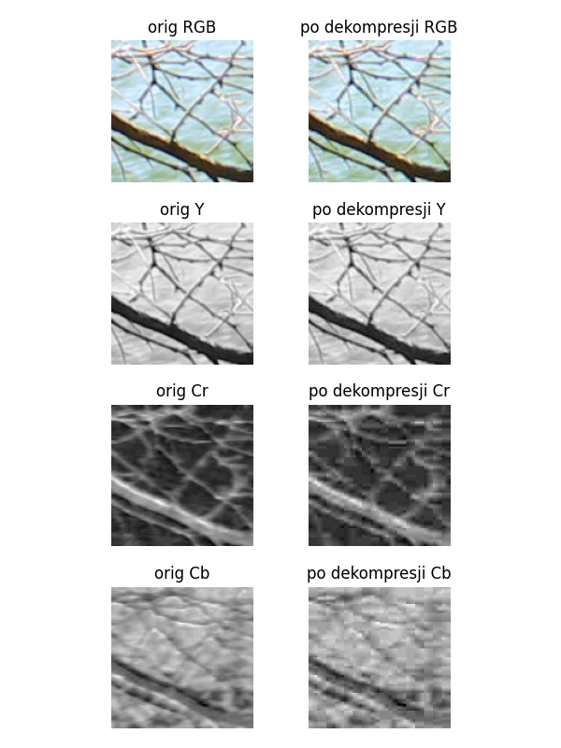

|  |  |  |  |
| --- | --- | --- | --- |
| Layer | Original Size | Compressed Size | Compression Ratio |
| Y | 16384 | 8762 | 53.48% |
| Cr | 16384 | 2372 | 14.48% |
| Cb | 16384 | 2354 | 14.37% |
| Total | 49152 | 13488 | 27.44% |

Compression Statistics - 4:4:4, Lumination 50% Quantization

RLE without layer compression:

|  |  |  |  |
| --- | --- | --- | --- |
| Layer | Original Size | Compressed Size | Compression Ratio |
| Y | 16384 | 30183 | 184.22% |
| Cr | 16384 | 22221 | 135.63% |
| Cb | 16384 | 23265 | 142.00% |
| Total | 49152 | 75669 | 153.95% |

### 4:2:2, Lumination 50% Quantization

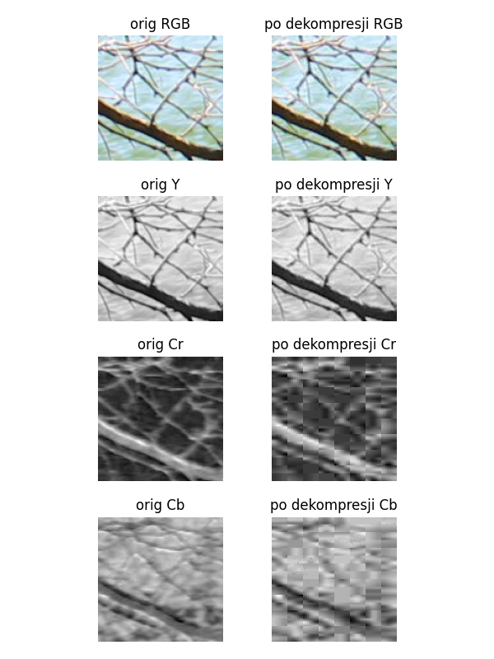

|  |  |  |  |
| --- | --- | --- | --- |
| Layer | Original Size | Compressed Size | Compression Ratio |
| Y | 16384 | 8762 | 53.48% |
| Cr | 8192 | 1374 | 16.77% |
| Cb | 8192 | 1308 | 15.97% |
| Total | 32768 | 11444 | 34.92% |

Compression Statistics - 4:2:2, Lumination 50% Quantization

RLE without layer compression:

|  |  |  |  |
| --- | --- | --- | --- |
| Layer | Original Size | Compressed Size | Compression Ratio |
| Y | 16384 | 30183 | 184.22% |
| Cr | 16384 | 22221 | 135.63% |
| Cb | 16384 | 23265 | 142.00% |
| Total | 49152 | 75669 | 153.95% |

## BIG_0003.jpg fragment: x=765, y=1995, width=128, height=128

### 4:4:4, neutral Quantization

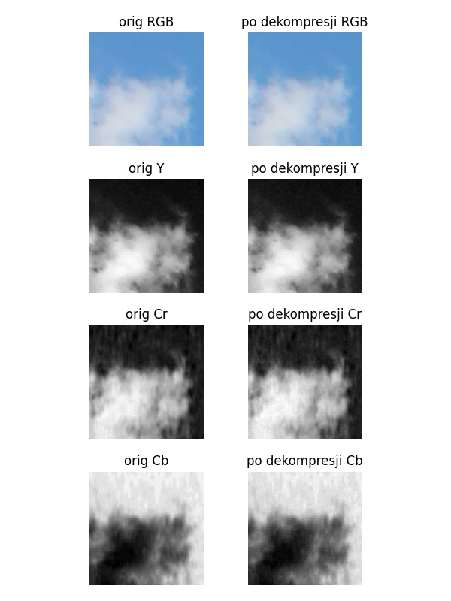

|  |  |  |  |
| --- | --- | --- | --- |
| Layer | Original Size | Compressed Size | Compression Ratio |
| Y | 16384 | 21636 | 132.06% |
| Cr | 16384 | 13642 | 83.26% |
| Cb | 16384 | 13174 | 80.41% |
| Total | 49152 | 48452 | 98.58% |

Compression Statistics - 4:4:4, neutral Quantization

RLE without layer compression:

|  |  |  |  |
| --- | --- | --- | --- |
| Layer | Original Size | Compressed Size | Compression Ratio |
| Y | 16384 | 22587 | 137.86% |
| Cr | 16384 | 16949 | 103.45% |
| Cb | 16384 | 15327 | 93.55% |
| Total | 49152 | 54863 | 111.62% |

### 4:2:2, neutral Quantization

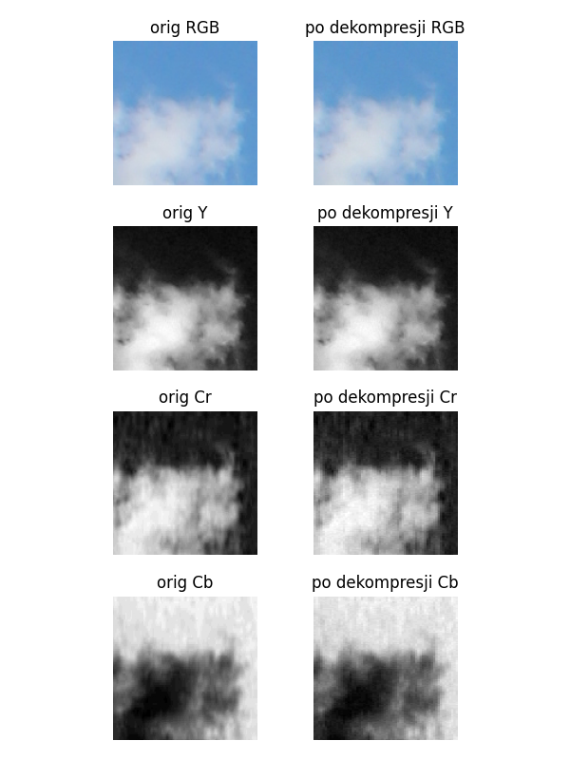

|  |  |  |  |
| --- | --- | --- | --- |
| Layer | Original Size | Compressed Size | Compression Ratio |
| Y | 16384 | 21636 | 132.06% |
| Cr | 8192 | 8120 | 99.12% |
| Cb | 8192 | 7750 | 94.60% |
| Total | 32768 | 37506 | 114.46% |

Compression Statistics - 4:2:2, neutral Quantization

RLE without layer compression:

|  |  |  |  |
| --- | --- | --- | --- |
| Layer | Original Size | Compressed Size | Compression Ratio |
| Y | 16384 | 22587 | 137.86% |
| Cr | 16384 | 16949 | 103.45% |
| Cb | 16384 | 15327 | 93.55% |
| Total | 49152 | 54863 | 111.62% |

### 4:4:4, Lumination 50% Quantization

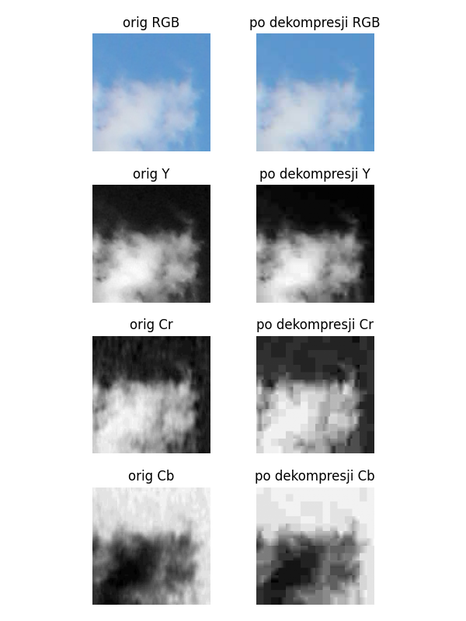

|  |  |  |  |
| --- | --- | --- | --- |
| Layer | Original Size | Compressed Size | Compression Ratio |
| Y | 16384 | 2336 | 14.26% |
| Cr | 16384 | 1348 | 8.23% |
| Cb | 16384 | 1330 | 8.12% |
| Total | 49152 | 5014 | 10.20% |

Compression Statistics - 4:4:4, Lumination 50% Quantization

RLE without layer compression:

|  |  |  |  |
| --- | --- | --- | --- |
| Layer | Original Size | Compressed Size | Compression Ratio |
| Y | 16384 | 22587 | 137.86% |
| Cr | 16384 | 16949 | 103.45% |
| Cb | 16384 | 15327 | 93.55% |
| Total | 49152 | 54863 | 111.62% |

### 4:2:2, Lumination 50% Quantization

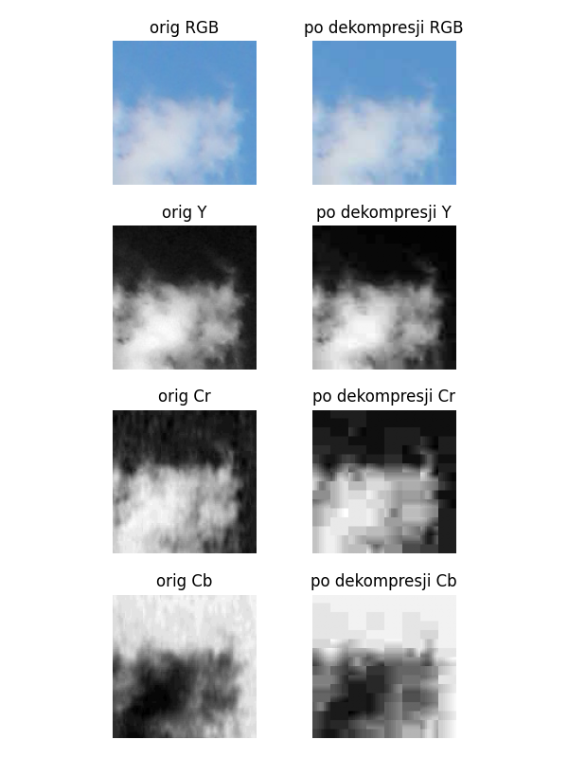

|  |  |  |  |
| --- | --- | --- | --- |
| Layer | Original Size | Compressed Size | Compression Ratio |
| Y | 16384 | 2336 | 14.26% |
| Cr | 8192 | 720 | 8.79% |
| Cb | 8192 | 720 | 8.79% |
| Total | 32768 | 3776 | 11.52% |

Compression Statistics - 4:2:2, Lumination 50% Quantization

RLE without layer compression:

|  |  |  |  |
| --- | --- | --- | --- |
| Layer | Original Size | Compressed Size | Compression Ratio |
| Y | 16384 | 22587 | 137.86% |
| Cr | 16384 | 16949 | 103.45% |
| Cb | 16384 | 15327 | 93.55% |
| Total | 49152 | 54863 | 111.62% |

## BIG_0003.jpg fragment: x=247, y=2509, width=128, height=128

### 4:4:4, neutral Quantization

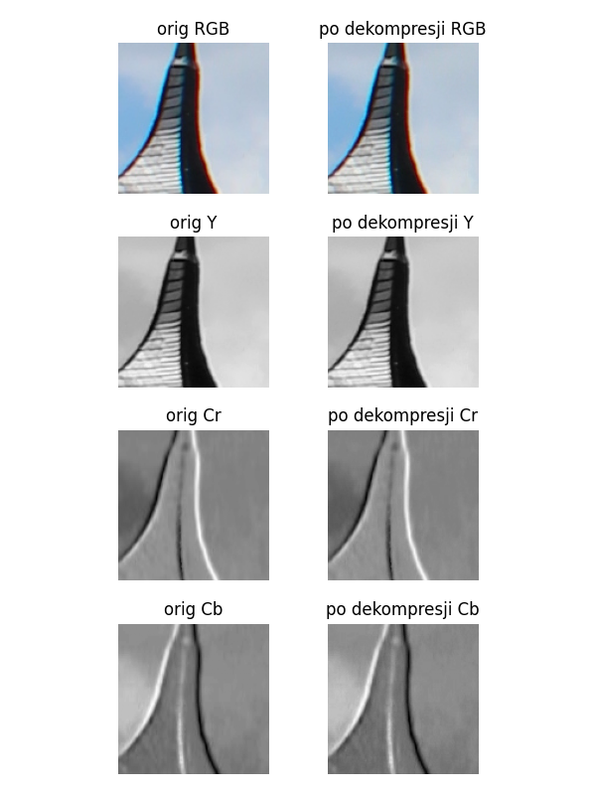

|  |  |  |  |
| --- | --- | --- | --- |
| Layer | Original Size | Compressed Size | Compression Ratio |
| Y | 16384 | 22748 | 138.84% |
| Cr | 16384 | 15630 | 95.40% |
| Cb | 16384 | 14246 | 86.95% |
| Total | 49152 | 52624 | 107.06% |

Compression Statistics - 4:4:4, neutral Quantization

RLE without layer compression:

|  |  |  |  |
| --- | --- | --- | --- |
| Layer | Original Size | Compressed Size | Compression Ratio |
| Y | 16384 | 22289 | 136.04% |
| Cr | 16384 | 18577 | 113.39% |
| Cb | 16384 | 17029 | 103.94% |
| Total | 49152 | 57895 | 117.79% |

### 4:2:2, neutral Quantization

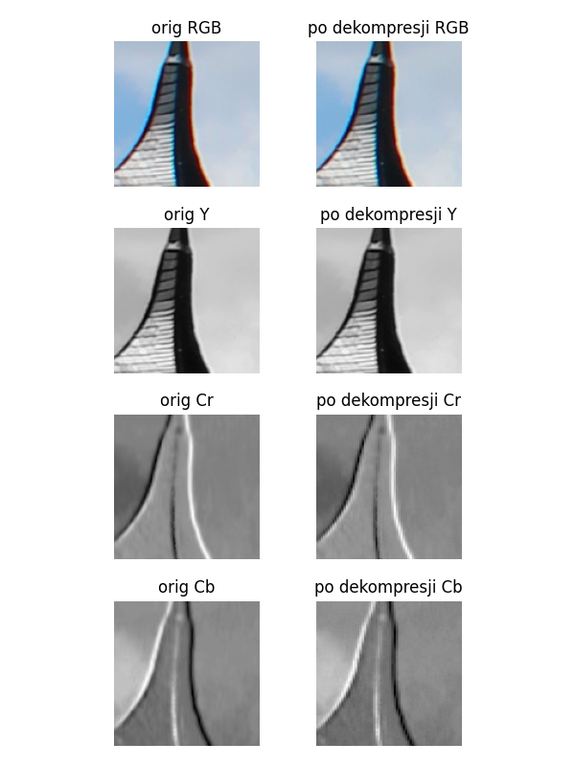

|  |  |  |  |
| --- | --- | --- | --- |
| Layer | Original Size | Compressed Size | Compression Ratio |
| Y | 16384 | 22748 | 138.84% |
| Cr | 8192 | 8830 | 107.79% |
| Cb | 8192 | 8358 | 102.03% |
| Total | 32768 | 39936 | 121.88% |

Compression Statistics - 4:2:2, neutral Quantization

RLE without layer compression:

|  |  |  |  |
| --- | --- | --- | --- |
| Layer | Original Size | Compressed Size | Compression Ratio |
| Y | 16384 | 22289 | 136.04% |
| Cr | 16384 | 18577 | 113.39% |
| Cb | 16384 | 17029 | 103.94% |
| Total | 49152 | 57895 | 117.79% |

### 4:4:4, Lumination 50% Quantization

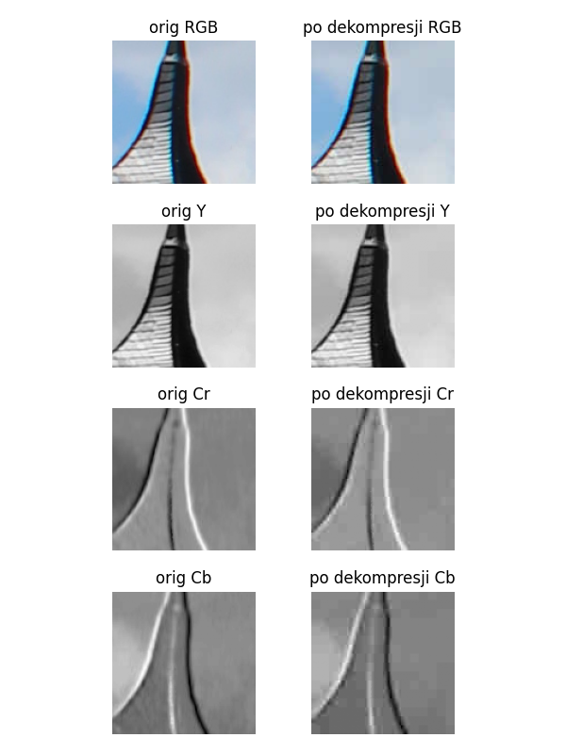

|  |  |  |  |
| --- | --- | --- | --- |
| Layer | Original Size | Compressed Size | Compression Ratio |
| Y | 16384 | 4038 | 24.65% |
| Cr | 16384 | 1670 | 10.19% |
| Cb | 16384 | 1538 | 9.39% |
| Total | 49152 | 7246 | 14.74% |

Compression Statistics - 4:4:4, Lumination 50% Quantization

RLE without layer compression:

|  |  |  |  |
| --- | --- | --- | --- |
| Layer | Original Size | Compressed Size | Compression Ratio |
| Y | 16384 | 22289 | 136.04% |
| Cr | 16384 | 18577 | 113.39% |
| Cb | 16384 | 17029 | 103.94% |
| Total | 49152 | 57895 | 117.79% |

### 4:2:2, Lumination 50% Quantization

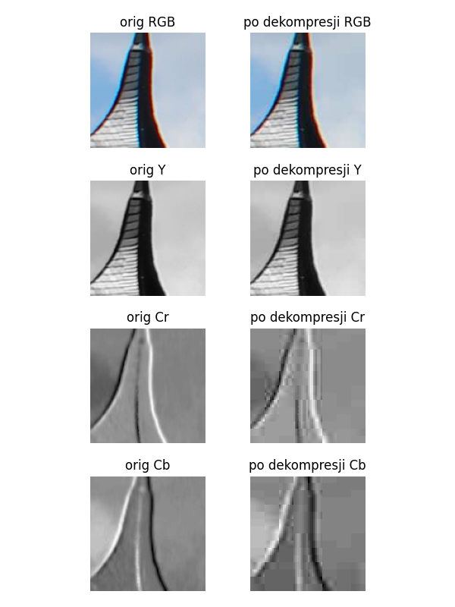

|  |  |  |  |
| --- | --- | --- | --- |
| Layer | Original Size | Compressed Size | Compression Ratio |
| Y | 16384 | 4038 | 24.65% |
| Cr | 8192 | 1056 | 12.89% |
| Cb | 8192 | 882 | 10.77% |
| Total | 32768 | 5976 | 18.24% |

Compression Statistics - 4:2:2, Lumination 50% Quantization

RLE without layer compression:

|  |  |  |  |
| --- | --- | --- | --- |
| Layer | Original Size | Compressed Size | Compression Ratio |
| Y | 16384 | 22289 | 136.04% |
| Cr | 16384 | 18577 | 113.39% |
| Cb | 16384 | 17029 | 103.94% |
| Total | 49152 | 57895 | 117.79% |

## BIG_0003.jpg fragment: x=1171, y=3602, width=128, height=128

### 4:4:4, neutral Quantization

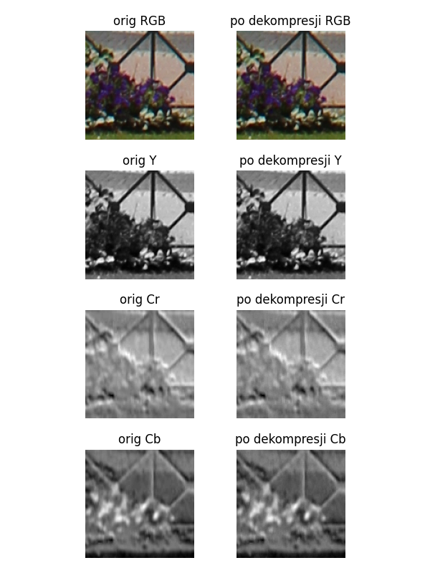

|  |  |  |  |
| --- | --- | --- | --- |
| Layer | Original Size | Compressed Size | Compression Ratio |
| Y | 16384 | 29944 | 182.76% |
| Cr | 16384 | 19040 | 116.21% |
| Cb | 16384 | 18534 | 113.12% |
| Total | 49152 | 67518 | 137.37% |

Compression Statistics - 4:4:4, neutral Quantization

RLE without layer compression:

|  |  |  |  |
| --- | --- | --- | --- |
| Layer | Original Size | Compressed Size | Compression Ratio |
| Y | 16384 | 30329 | 185.11% |
| Cr | 16384 | 24533 | 149.74% |
| Cb | 16384 | 24519 | 149.65% |
| Total | 49152 | 79381 | 161.50% |

### 4:2:2, neutral Quantization

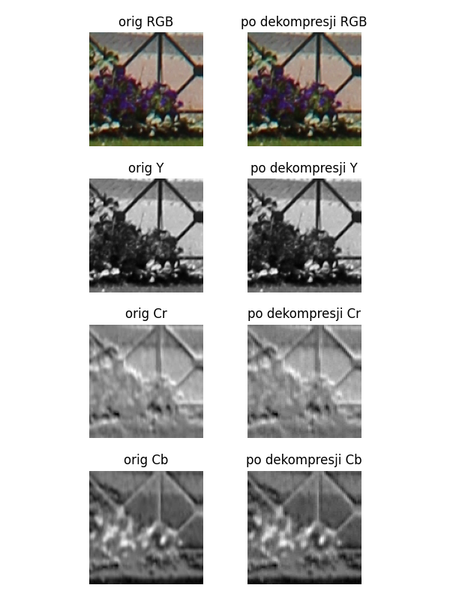

|  |  |  |  |
| --- | --- | --- | --- |
| Layer | Original Size | Compressed Size | Compression Ratio |
| Y | 16384 | 29944 | 182.76% |
| Cr | 8192 | 10734 | 131.03% |
| Cb | 8192 | 10428 | 127.29% |
| Total | 32768 | 51106 | 155.96% |

Compression Statistics - 4:2:2, neutral Quantization

RLE without layer compression:

|  |  |  |  |
| --- | --- | --- | --- |
| Layer | Original Size | Compressed Size | Compression Ratio |
| Y | 16384 | 30329 | 185.11% |
| Cr | 16384 | 24533 | 149.74% |
| Cb | 16384 | 24519 | 149.65% |
| Total | 49152 | 79381 | 161.50% |

### 4:4:4, Lumination 50% Quantization

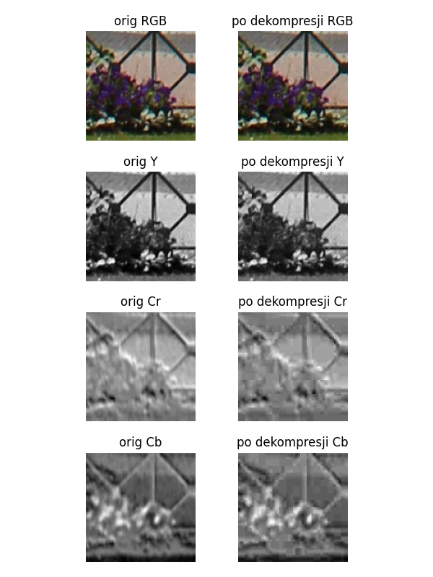

|  |  |  |  |
| --- | --- | --- | --- |
| Layer | Original Size | Compressed Size | Compression Ratio |
| Y | 16384 | 7716 | 47.09% |
| Cr | 16384 | 2186 | 13.34% |
| Cb | 16384 | 2272 | 13.87% |
| Total | 49152 | 12174 | 24.77% |

Compression Statistics - 4:4:4, Lumination 50% Quantization

RLE without layer compression:

|  |  |  |  |
| --- | --- | --- | --- |
| Layer | Original Size | Compressed Size | Compression Ratio |
| Y | 16384 | 30329 | 185.11% |
| Cr | 16384 | 24533 | 149.74% |
| Cb | 16384 | 24519 | 149.65% |
| Total | 49152 | 79381 | 161.50% |

### 4:2:2, Lumination 50% Quantization

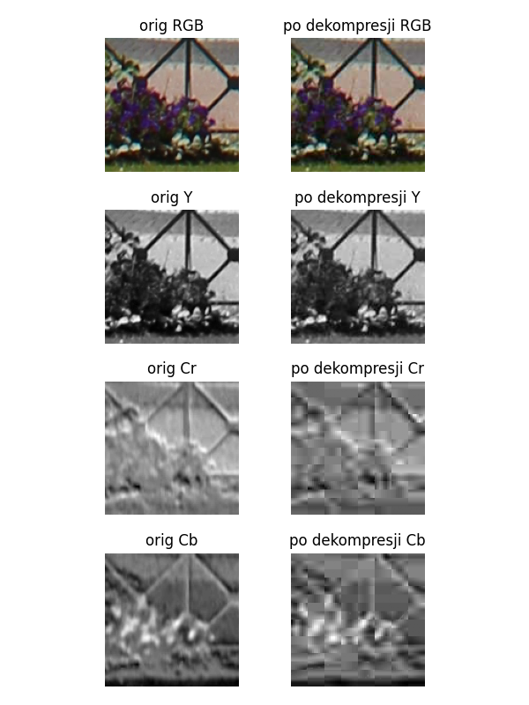

|  |  |  |  |
| --- | --- | --- | --- |
| Layer | Original Size | Compressed Size | Compression Ratio |
| Y | 16384 | 7716 | 47.09% |
| Cr | 8192 | 1224 | 14.94% |
| Cb | 8192 | 1282 | 15.65% |
| Total | 32768 | 10222 | 31.20% |

Compression Statistics - 4:2:2, Lumination 50% Quantization

RLE without layer compression:

|  |  |  |  |
| --- | --- | --- | --- |
| Layer | Original Size | Compressed Size | Compression Ratio |
| Y | 16384 | 30329 | 185.11% |
| Cr | 16384 | 24533 | 149.74% |
| Cb | 16384 | 24519 | 149.65% |
| Total | 49152 | 79381 | 161.50% |

## BIG_0003.jpg fragment: x=2605, y=3364, width=128, height=128

### 4:4:4, neutral Quantization

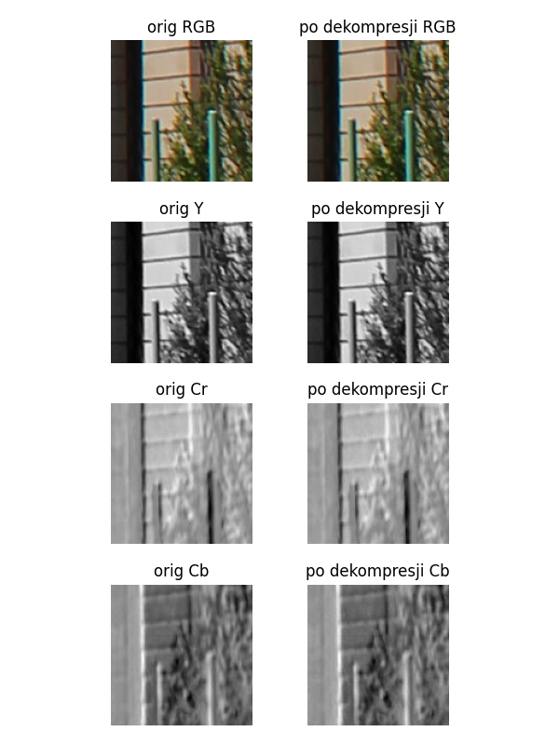

|  |  |  |  |
| --- | --- | --- | --- |
| Layer | Original Size | Compressed Size | Compression Ratio |
| Y | 16384 | 28742 | 175.43% |
| Cr | 16384 | 18116 | 110.57% |
| Cb | 16384 | 17466 | 106.60% |
| Total | 49152 | 64324 | 130.87% |

Compression Statistics - 4:4:4, neutral Quantization

RLE without layer compression:

|  |  |  |  |
| --- | --- | --- | --- |
| Layer | Original Size | Compressed Size | Compression Ratio |
| Y | 16384 | 29725 | 181.43% |
| Cr | 16384 | 26237 | 160.14% |
| Cb | 16384 | 25087 | 153.12% |
| Total | 49152 | 81049 | 164.89% |

### 4:2:2, neutral Quantization

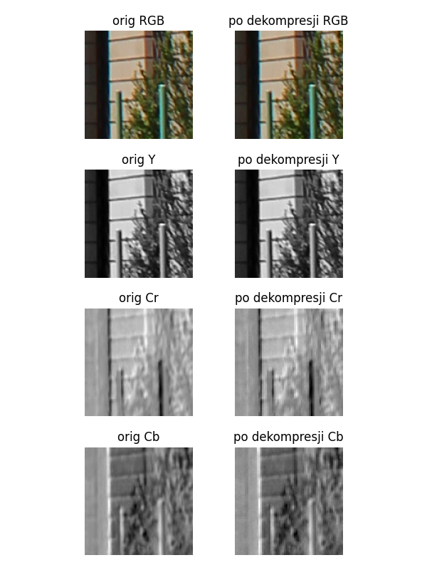

|  |  |  |  |
| --- | --- | --- | --- |
| Layer | Original Size | Compressed Size | Compression Ratio |
| Y | 16384 | 28742 | 175.43% |
| Cr | 8192 | 9976 | 121.78% |
| Cb | 8192 | 9638 | 117.65% |
| Total | 32768 | 48356 | 147.57% |

Compression Statistics - 4:2:2, neutral Quantization

RLE without layer compression:

|  |  |  |  |
| --- | --- | --- | --- |
| Layer | Original Size | Compressed Size | Compression Ratio |
| Y | 16384 | 29725 | 181.43% |
| Cr | 16384 | 26237 | 160.14% |
| Cb | 16384 | 25087 | 153.12% |
| Total | 49152 | 81049 | 164.89% |

### 4:4:4, Lumination 50% Quantization

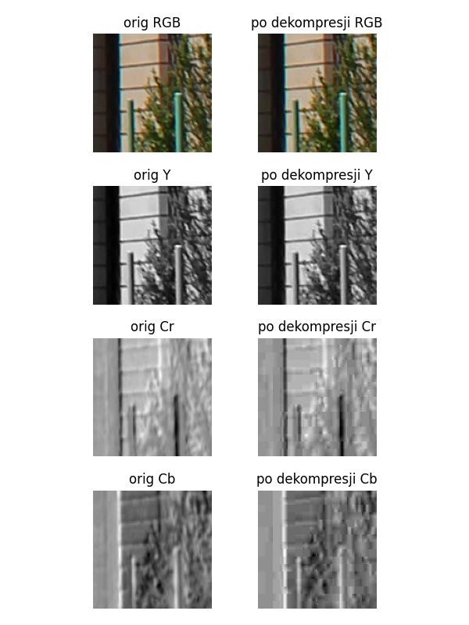

|  |  |  |  |
| --- | --- | --- | --- |
| Layer | Original Size | Compressed Size | Compression Ratio |
| Y | 16384 | 7262 | 44.32% |
| Cr | 16384 | 2138 | 13.05% |
| Cb | 16384 | 2082 | 12.71% |
| Total | 49152 | 11482 | 23.36% |

Compression Statistics - 4:4:4, Lumination 50% Quantization

RLE without layer compression:

|  |  |  |  |
| --- | --- | --- | --- |
| Layer | Original Size | Compressed Size | Compression Ratio |
| Y | 16384 | 29725 | 181.43% |
| Cr | 16384 | 26237 | 160.14% |
| Cb | 16384 | 25087 | 153.12% |
| Total | 49152 | 81049 | 164.89% |

### 4:2:2, Lumination 50% Quantization

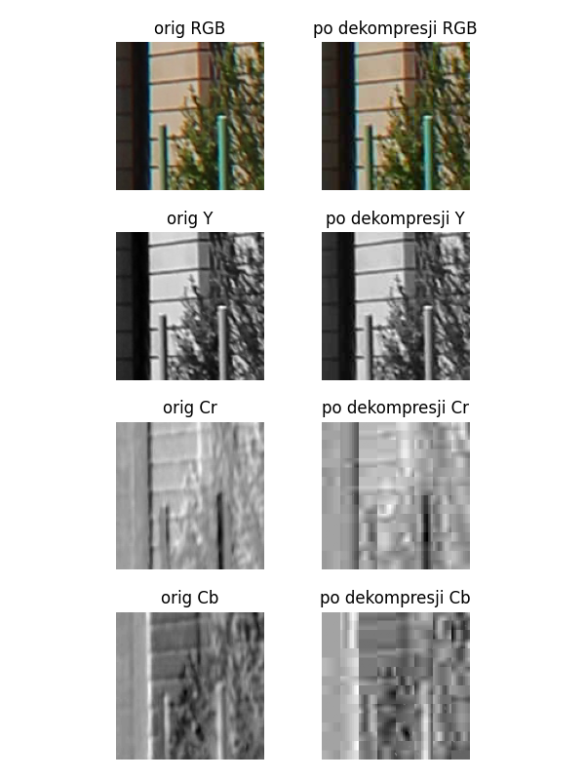

|  |  |  |  |
| --- | --- | --- | --- |
| Layer | Original Size | Compressed Size | Compression Ratio |
| Y | 16384 | 7262 | 44.32% |
| Cr | 8192 | 1146 | 13.99% |
| Cb | 8192 | 1152 | 14.06% |
| Total | 32768 | 9560 | 29.17% |

Compression Statistics - 4:2:2, Lumination 50% Quantization

RLE without layer compression:

|  |  |  |  |
| --- | --- | --- | --- |
| Layer | Original Size | Compressed Size | Compression Ratio |
| Y | 16384 | 29725 | 181.43% |
| Cr | 16384 | 26237 | 160.14% |
| Cb | 16384 | 25087 | 153.12% |
| Total | 49152 | 81049 | 164.89% |

## BIG_0004.png fragment: x=79, y=312, width=128, height=128

### 4:4:4, neutral Quantization

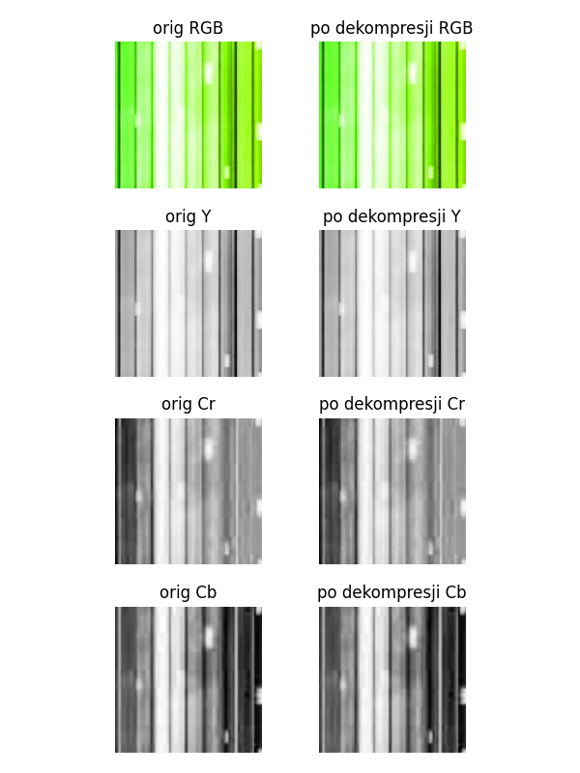

|  |  |  |  |
| --- | --- | --- | --- |
| Layer | Original Size | Compressed Size | Compression Ratio |
| Y | 16384 | 12836 | 78.34% |
| Cr | 16384 | 12748 | 77.81% |
| Cb | 16384 | 15548 | 94.90% |
| Total | 49152 | 41132 | 83.68% |

Compression Statistics - 4:4:4, neutral Quantization

RLE without layer compression:

|  |  |  |  |
| --- | --- | --- | --- |
| Layer | Original Size | Compressed Size | Compression Ratio |
| Y | 16384 | 29709 | 181.33% |
| Cr | 16384 | 28561 | 174.32% |
| Cb | 16384 | 29829 | 182.06% |
| Total | 49152 | 88099 | 179.24% |

### 4:2:2, neutral Quantization

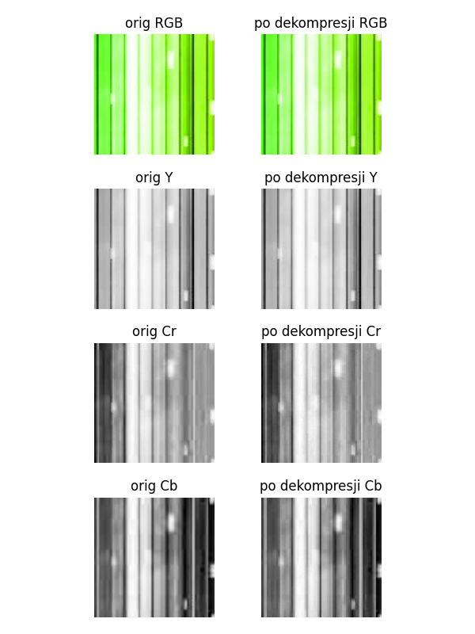

|  |  |  |  |
| --- | --- | --- | --- |
| Layer | Original Size | Compressed Size | Compression Ratio |
| Y | 16384 | 12836 | 78.34% |
| Cr | 8192 | 6922 | 84.50% |
| Cb | 8192 | 8270 | 100.95% |
| Total | 32768 | 28028 | 85.53% |

Compression Statistics - 4:2:2, neutral Quantization

RLE without layer compression:

|  |  |  |  |
| --- | --- | --- | --- |
| Layer | Original Size | Compressed Size | Compression Ratio |
| Y | 16384 | 29709 | 181.33% |
| Cr | 16384 | 28561 | 174.32% |
| Cb | 16384 | 29829 | 182.06% |
| Total | 49152 | 88099 | 179.24% |

### 4:4:4, Lumination 50% Quantization

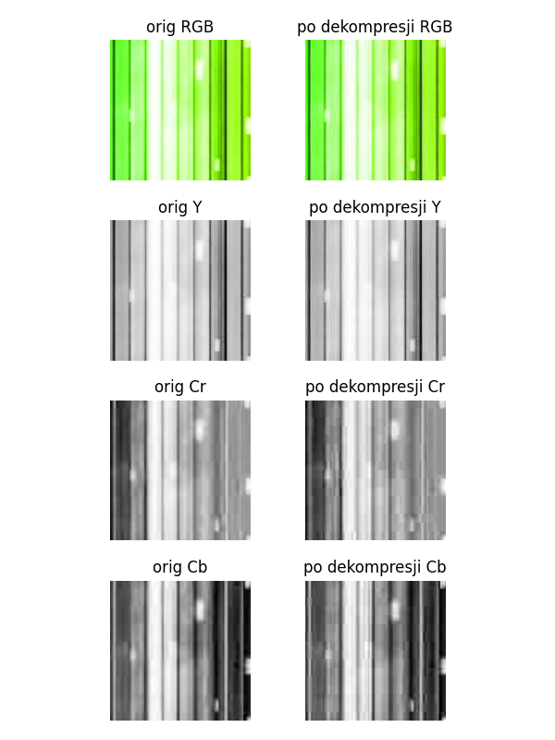

|  |  |  |  |
| --- | --- | --- | --- |
| Layer | Original Size | Compressed Size | Compression Ratio |
| Y | 16384 | 4608 | 28.12% |
| Cr | 16384 | 2298 | 14.03% |
| Cb | 16384 | 2912 | 17.77% |
| Total | 49152 | 9818 | 19.97% |

Compression Statistics - 4:4:4, Lumination 50% Quantization

RLE without layer compression:

|  |  |  |  |
| --- | --- | --- | --- |
| Layer | Original Size | Compressed Size | Compression Ratio |
| Y | 16384 | 29709 | 181.33% |
| Cr | 16384 | 28561 | 174.32% |
| Cb | 16384 | 29829 | 182.06% |
| Total | 49152 | 88099 | 179.24% |

### 4:2:2, Lumination 50% Quantization

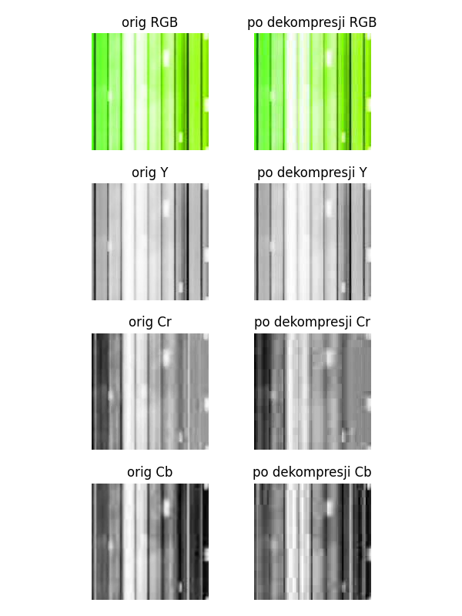

|  |  |  |  |
| --- | --- | --- | --- |
| Layer | Original Size | Compressed Size | Compression Ratio |
| Y | 16384 | 4608 | 28.12% |
| Cr | 8192 | 1254 | 15.31% |
| Cb | 8192 | 1724 | 21.04% |
| Total | 32768 | 7586 | 23.15% |

Compression Statistics - 4:2:2, Lumination 50% Quantization

RLE without layer compression:

|  |  |  |  |
| --- | --- | --- | --- |
| Layer | Original Size | Compressed Size | Compression Ratio |
| Y | 16384 | 29709 | 181.33% |
| Cr | 16384 | 28561 | 174.32% |
| Cb | 16384 | 29829 | 182.06% |
| Total | 49152 | 88099 | 179.24% |

## BIG_0004.png fragment: x=163, y=622, width=128, height=128

### 4:4:4, neutral Quantization

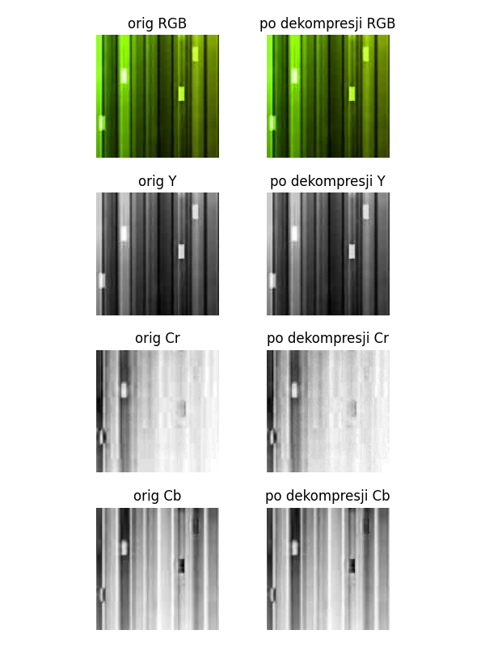

|  |  |  |  |
| --- | --- | --- | --- |
| Layer | Original Size | Compressed Size | Compression Ratio |
| Y | 16384 | 23818 | 145.37% |
| Cr | 16384 | 12720 | 77.64% |
| Cb | 16384 | 19272 | 117.63% |
| Total | 49152 | 55810 | 113.55% |

Compression Statistics - 4:4:4, neutral Quantization

RLE without layer compression:

|  |  |  |  |
| --- | --- | --- | --- |
| Layer | Original Size | Compressed Size | Compression Ratio |
| Y | 16384 | 31371 | 191.47% |
| Cr | 16384 | 22323 | 136.25% |
| Cb | 16384 | 30187 | 184.25% |
| Total | 49152 | 83881 | 170.66% |

### 4:2:2, neutral Quantization

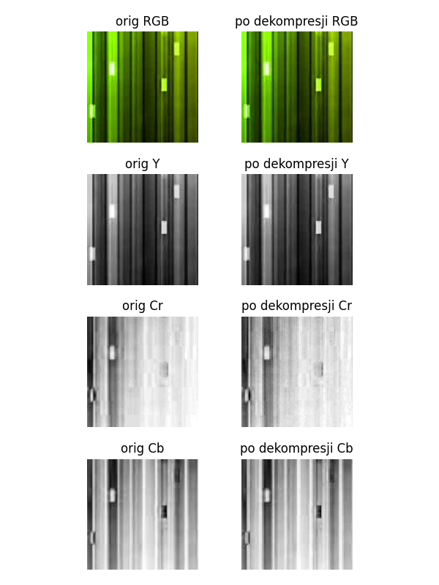

|  |  |  |  |
| --- | --- | --- | --- |
| Layer | Original Size | Compressed Size | Compression Ratio |
| Y | 16384 | 23818 | 145.37% |
| Cr | 8192 | 6796 | 82.96% |
| Cb | 8192 | 10106 | 123.36% |
| Total | 32768 | 40720 | 124.27% |

Compression Statistics - 4:2:2, neutral Quantization

RLE without layer compression:

|  |  |  |  |
| --- | --- | --- | --- |
| Layer | Original Size | Compressed Size | Compression Ratio |
| Y | 16384 | 31371 | 191.47% |
| Cr | 16384 | 22323 | 136.25% |
| Cb | 16384 | 30187 | 184.25% |
| Total | 49152 | 83881 | 170.66% |

### 4:4:4, Lumination 50% Quantization

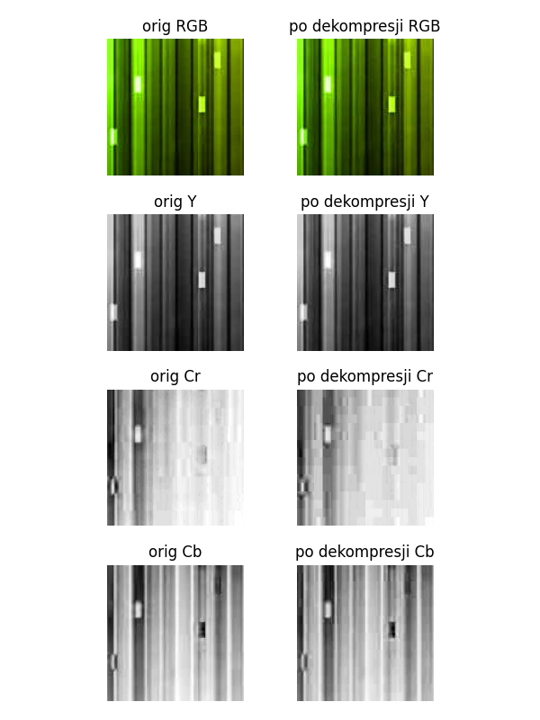

|  |  |  |  |
| --- | --- | --- | --- |
| Layer | Original Size | Compressed Size | Compression Ratio |
| Y | 16384 | 5032 | 30.71% |
| Cr | 16384 | 1482 | 9.05% |
| Cb | 16384 | 2798 | 17.08% |
| Total | 49152 | 9312 | 18.95% |

Compression Statistics - 4:4:4, Lumination 50% Quantization

RLE without layer compression:

|  |  |  |  |
| --- | --- | --- | --- |
| Layer | Original Size | Compressed Size | Compression Ratio |
| Y | 16384 | 31371 | 191.47% |
| Cr | 16384 | 22323 | 136.25% |
| Cb | 16384 | 30187 | 184.25% |
| Total | 49152 | 83881 | 170.66% |

### 4:2:2, Lumination 50% Quantization

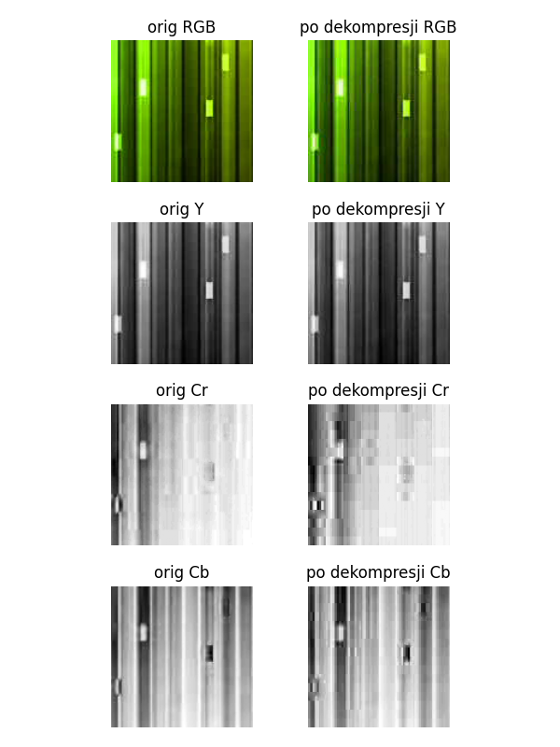

|  |  |  |  |
| --- | --- | --- | --- |
| Layer | Original Size | Compressed Size | Compression Ratio |
| Y | 16384 | 5032 | 30.71% |
| Cr | 8192 | 752 | 9.18% |
| Cb | 8192 | 1610 | 19.65% |
| Total | 32768 | 7394 | 22.56% |

Compression Statistics - 4:2:2, Lumination 50% Quantization

RLE without layer compression:

|  |  |  |  |
| --- | --- | --- | --- |
| Layer | Original Size | Compressed Size | Compression Ratio |
| Y | 16384 | 31371 | 191.47% |
| Cr | 16384 | 22323 | 136.25% |
| Cb | 16384 | 30187 | 184.25% |
| Total | 49152 | 83881 | 170.66% |

## BIG_0004.png fragment: x=861, y=60, width=128, height=128

### 4:4:4, neutral Quantization

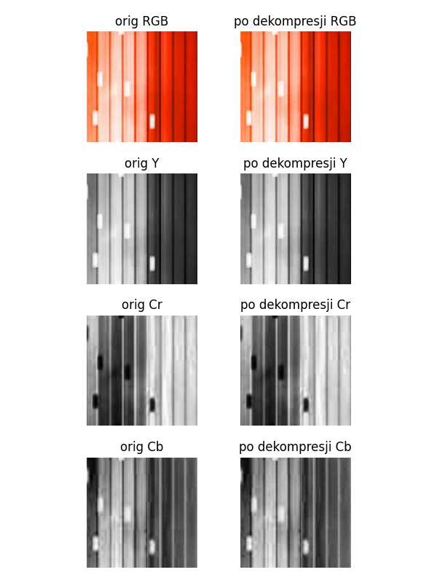

|  |  |  |  |
| --- | --- | --- | --- |
| Layer | Original Size | Compressed Size | Compression Ratio |
| Y | 16384 | 22594 | 137.90% |
| Cr | 16384 | 17874 | 109.09% |
| Cb | 16384 | 15876 | 96.90% |
| Total | 49152 | 56344 | 114.63% |

Compression Statistics - 4:4:4, neutral Quantization

RLE without layer compression:

|  |  |  |  |
| --- | --- | --- | --- |
| Layer | Original Size | Compressed Size | Compression Ratio |
| Y | 16384 | 31075 | 189.67% |
| Cr | 16384 | 29873 | 182.33% |
| Cb | 16384 | 28255 | 172.45% |
| Total | 49152 | 89203 | 181.48% |

### 4:2:2, neutral Quantization

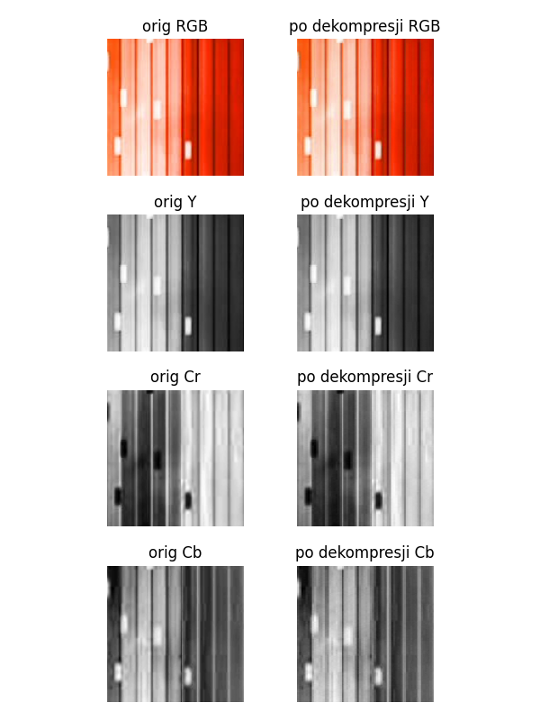

|  |  |  |  |
| --- | --- | --- | --- |
| Layer | Original Size | Compressed Size | Compression Ratio |
| Y | 16384 | 22594 | 137.90% |
| Cr | 8192 | 9800 | 119.63% |
| Cb | 8192 | 8662 | 105.74% |
| Total | 32768 | 41056 | 125.29% |

Compression Statistics - 4:2:2, neutral Quantization

RLE without layer compression:

|  |  |  |  |
| --- | --- | --- | --- |
| Layer | Original Size | Compressed Size | Compression Ratio |
| Y | 16384 | 31075 | 189.67% |
| Cr | 16384 | 29873 | 182.33% |
| Cb | 16384 | 28255 | 172.45% |
| Total | 49152 | 89203 | 181.48% |

### 4:4:4, Lumination 50% Quantization

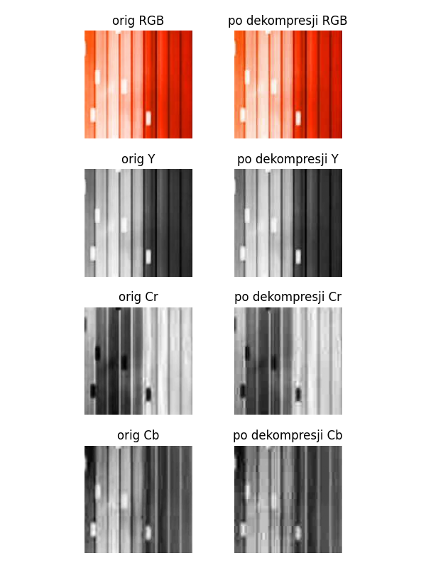

|  |  |  |  |
| --- | --- | --- | --- |
| Layer | Original Size | Compressed Size | Compression Ratio |
| Y | 16384 | 4588 | 28.00% |
| Cr | 16384 | 2734 | 16.69% |
| Cb | 16384 | 2318 | 14.15% |
| Total | 49152 | 9640 | 19.61% |

Compression Statistics - 4:4:4, Lumination 50% Quantization

RLE without layer compression:

|  |  |  |  |
| --- | --- | --- | --- |
| Layer | Original Size | Compressed Size | Compression Ratio |
| Y | 16384 | 31075 | 189.67% |
| Cr | 16384 | 29873 | 182.33% |
| Cb | 16384 | 28255 | 172.45% |
| Total | 49152 | 89203 | 181.48% |

### 4:2:2, Lumination 50% Quantization

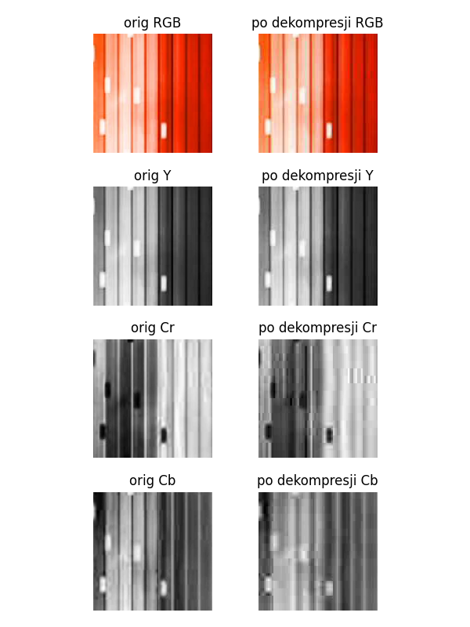

|  |  |  |  |
| --- | --- | --- | --- |
| Layer | Original Size | Compressed Size | Compression Ratio |
| Y | 16384 | 4588 | 28.00% |
| Cr | 8192 | 1664 | 20.31% |
| Cb | 8192 | 1350 | 16.48% |
| Total | 32768 | 7602 | 23.20% |

Compression Statistics - 4:2:2, Lumination 50% Quantization

RLE without layer compression:

|  |  |  |  |
| --- | --- | --- | --- |
| Layer | Original Size | Compressed Size | Compression Ratio |
| Y | 16384 | 31075 | 189.67% |
| Cr | 16384 | 29873 | 182.33% |
| Cb | 16384 | 28255 | 172.45% |
| Total | 49152 | 89203 | 181.48% |

## BIG_0004.png fragment: x=1684, y=506, width=128, height=128

### 4:4:4, neutral Quantization

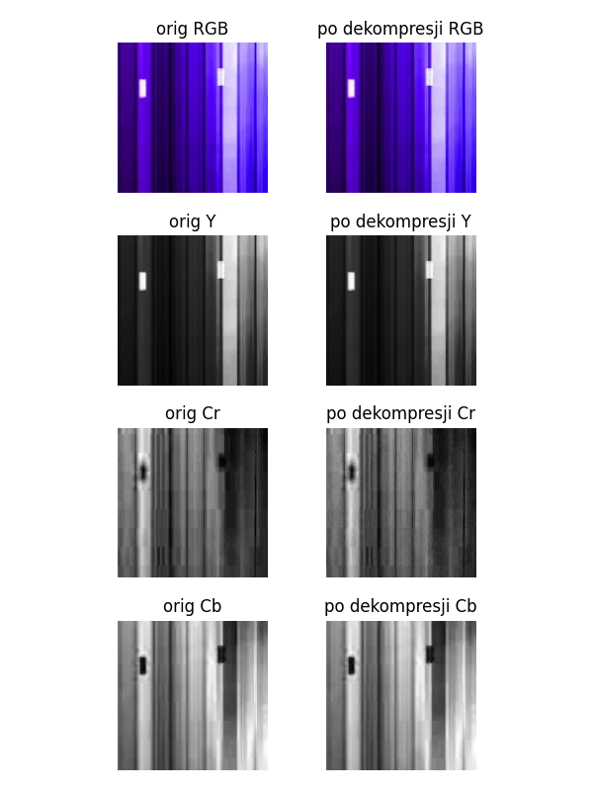

|  |  |  |  |
| --- | --- | --- | --- |
| Layer | Original Size | Compressed Size | Compression Ratio |
| Y | 16384 | 18664 | 113.92% |
| Cr | 16384 | 10910 | 66.59% |
| Cb | 16384 | 16954 | 103.48% |
| Total | 49152 | 46528 | 94.66% |

Compression Statistics - 4:4:4, neutral Quantization

RLE without layer compression:

|  |  |  |  |
| --- | --- | --- | --- |
| Layer | Original Size | Compressed Size | Compression Ratio |
| Y | 16384 | 29207 | 178.27% |
| Cr | 16384 | 24289 | 148.25% |
| Cb | 16384 | 29685 | 181.18% |
| Total | 49152 | 83181 | 169.23% |

### 4:2:2, neutral Quantization

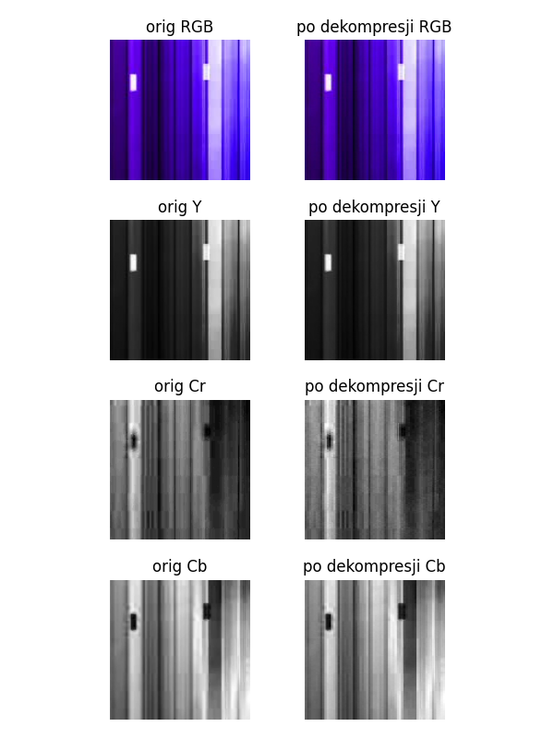

|  |  |  |  |
| --- | --- | --- | --- |
| Layer | Original Size | Compressed Size | Compression Ratio |
| Y | 16384 | 18664 | 113.92% |
| Cr | 8192 | 5638 | 68.82% |
| Cb | 8192 | 9030 | 110.23% |
| Total | 32768 | 33332 | 101.72% |

Compression Statistics - 4:2:2, neutral Quantization

RLE without layer compression:

|  |  |  |  |
| --- | --- | --- | --- |
| Layer | Original Size | Compressed Size | Compression Ratio |
| Y | 16384 | 29207 | 178.27% |
| Cr | 16384 | 24289 | 148.25% |
| Cb | 16384 | 29685 | 181.18% |
| Total | 49152 | 83181 | 169.23% |

### 4:4:4, Lumination 50% Quantization

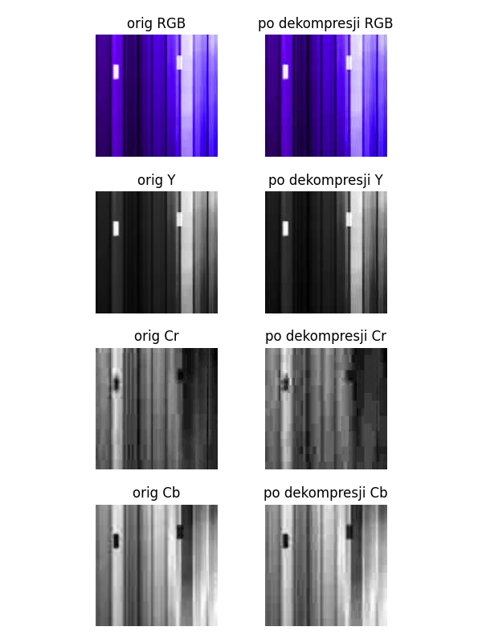

|  |  |  |  |
| --- | --- | --- | --- |
| Layer | Original Size | Compressed Size | Compression Ratio |
| Y | 16384 | 4272 | 26.07% |
| Cr | 16384 | 1582 | 9.66% |
| Cb | 16384 | 2686 | 16.39% |
| Total | 49152 | 8540 | 17.37% |

Compression Statistics - 4:4:4, Lumination 50% Quantization

RLE without layer compression:

|  |  |  |  |
| --- | --- | --- | --- |
| Layer | Original Size | Compressed Size | Compression Ratio |
| Y | 16384 | 29207 | 178.27% |
| Cr | 16384 | 24289 | 148.25% |
| Cb | 16384 | 29685 | 181.18% |
| Total | 49152 | 83181 | 169.23% |

### 4:2:2, Lumination 50% Quantization

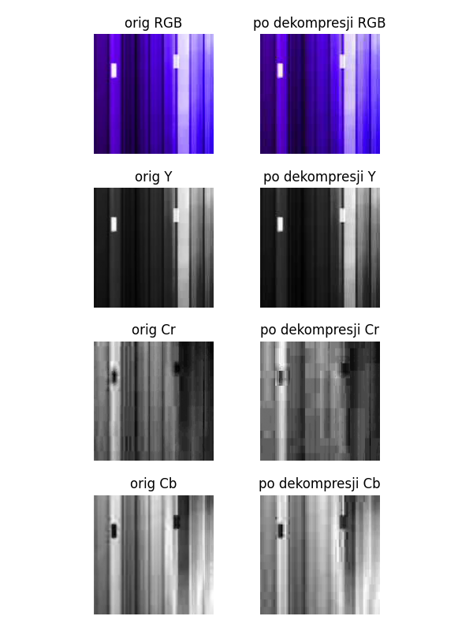

|  |  |  |  |
| --- | --- | --- | --- |
| Layer | Original Size | Compressed Size | Compression Ratio |
| Y | 16384 | 4272 | 26.07% |
| Cr | 8192 | 844 | 10.30% |
| Cb | 8192 | 1596 | 19.48% |
| Total | 32768 | 6712 | 20.48% |

Compression Statistics - 4:2:2, Lumination 50% Quantization

RLE without layer compression:

|  |  |  |  |
| --- | --- | --- | --- |
| Layer | Original Size | Compressed Size | Compression Ratio |
| Y | 16384 | 29207 | 178.27% |
| Cr | 16384 | 24289 | 148.25% |
| Cb | 16384 | 29685 | 181.18% |
| Total | 49152 | 83181 | 169.23% |